



**SUPPORTING DOCUMENTS FOR 7.1.1**

**TEL. NO. 01282-251256 (O)**

**E-mail-** [**principal.gcnnl@gmail.com**](mailto:principal.gcnnl@gmail.com) **Website : https://gcnnl.ac.in**



**MEASURES INITIATED BY THE INSTITUION FOR THE PROMOTION OF GENDER EQUITY: SPECIFIC FACILITIES FOR WOMEN**

Gender equality is one of the critical challenges facing society today. The institute conducts regular gender equity promotion programs. Our institution aims to maintain gender equity and social equity in imparting education. There are quite a good number of female & male students and staff members. Guest speakers from the prominent field are invited to speak on the given topic, highlighting women's importance and contribution to society.

The institute creates awareness among students about the gender imbalance in society and professional arenas for safety and security reasons. Being a women's institute, the safety and security of everyone on the campus are ensured. Gender equity is a way of life. The college encourages girls to participate in academic, cultural, sports, and social activities.The women empowerment cell,NCC,NSS organises various activities to sensitise and promote gender equity among students and staff.

**Women Cell and Anti-Ragging Cell,** Grievance Appeals and Redressal committee are established per government norms. The college ensures that there are no instances of ragging or Sexual Harassment on campus. Teachers perform proctorial duties throughout the campus area- rooms, corridors, labs, playground, library, outside the girls' shared room, etc. They take necessary action whenever needed. **CCTV Cameras** are installed at many places to ensure the safety and security of all students and staff members. The college is committed to providing a safe environment for this purpose. Students are aware of the'' Durga Shakti - App as per UGC guidelines. Anti-Ragging Committee is formed. The students at the entry- level sign affidavit and submit it to the University about non-involvement in ragging activities. The anti-Ragging committee makes sure that there are no instances of ragging any where among the students. The college is committed to providing a safe environment for this purpose students are aware of the APP.

There is a common room for girls students in the college for various activities such as poster making, speech, bhajan, etc., which the staff members and students monitor. There are separate washrooms for female teaching staff and students. There is an extensive library for

sitting and studying. The college is willing to nurture a healthy environment; for this purpose, a counselling cell is set up for the benefit of students. From time to time, girls are provided counselling if they face any problems regarding their studies or other personal issues. The safety and security of all the students, teachers,non-teaching staff, and visitors to the college are always the priority. To ensure a safe campus and a secure environment, the college embarked upon many facilities initiatives with the regular presence of a gatekeeper. The college has an Anti-Ragging and Sexual Harassment Committee to deal with the problems. Separate bathrooms are for the male-female, teaching, and non-teaching staff. Identity cards are issued to all the students.

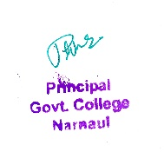

This document contains information regarding specific facilities provided for women in terms of :

* Safety and Security
* Counseling
* Details of Various Activities to Promote Gender Equity

**SAFETY AND SECURITY**

* As a Co-ed college, GC Narnaul takes responsibility for providing a safe space for its students to learn and grow.
* The high walls of the campus also prevent the trespassers from entering the college premises
* The safety and security of students is a priority at the college during events and fests when the outsiders are also invited to the college campus
* Not only is our institution committed to women’s safety within the college campus, we are also engaged in making our community and neighbourhood safe for all women.



**COUNSELLING**

* Student life today throws up numerous challenges owing to a fast-paced tempo, changing family dynamics, being away from home, increased competitiveness and social media.
* GC Narnaul recognizes that counseling is important for students to navigate these demands and achieve their academic potential. In keeping with its mission to provide for the all-round holistic development of women students, our institution offers formal in-house counseling.
* This Counseling is free and open to all students and staff and complete confidentiality is maintained. It has contributed greatly in promoting the psychological well-being of students, helping them achieve their academic, personal, and relational goals.
* Some of the recurring student concerns flagged by the College Counselors are: Time, Stress, and Relationship Management, Family Problems, Body Image, Self Confidence, Career Counseling and Teething Problems faced by first year and outstation students.

GC Narnaul also has a strong Mentor-Ward Programme that complements the teaching-learning exercise. Every student is paired with a faculty-mentor, thus giving them the opportunity to reach out for individual sessions for counsel.

* Gender Sensitization are organized from time to time.
* The various initiatives launched by the college underlines that it takes responsibility for disseminating information on counseling as well as dispelling the myths and stigma surrounding it very seriously. This has helped students understand the significance of counseling and work on their own fears and anxieties and achieve their best in both curricular and extra-curricular activities.



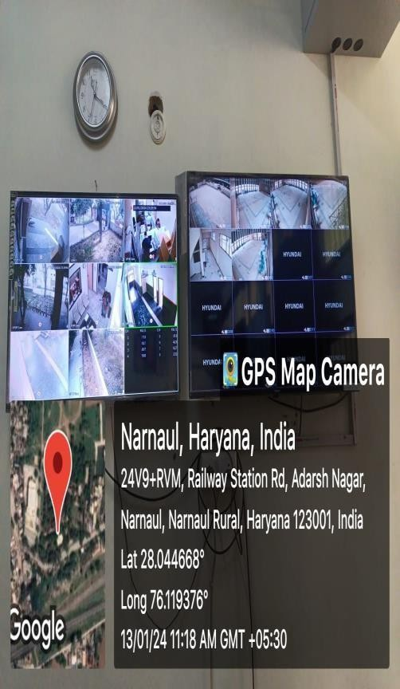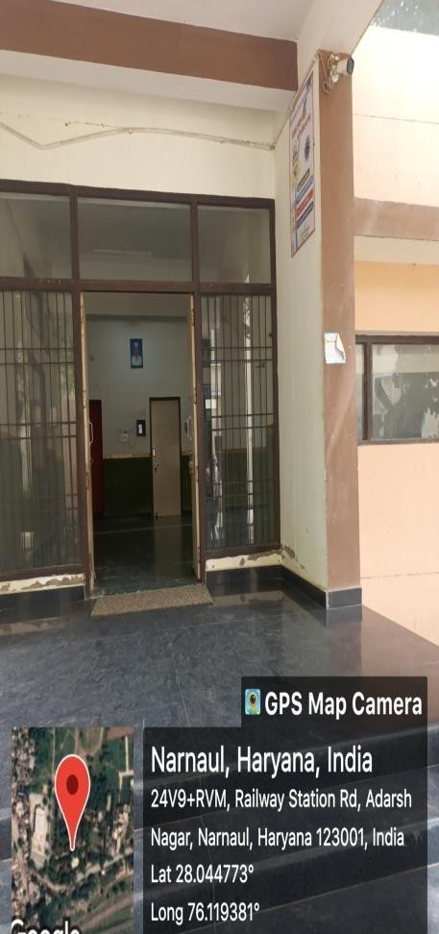

**CCTV Surveillance**

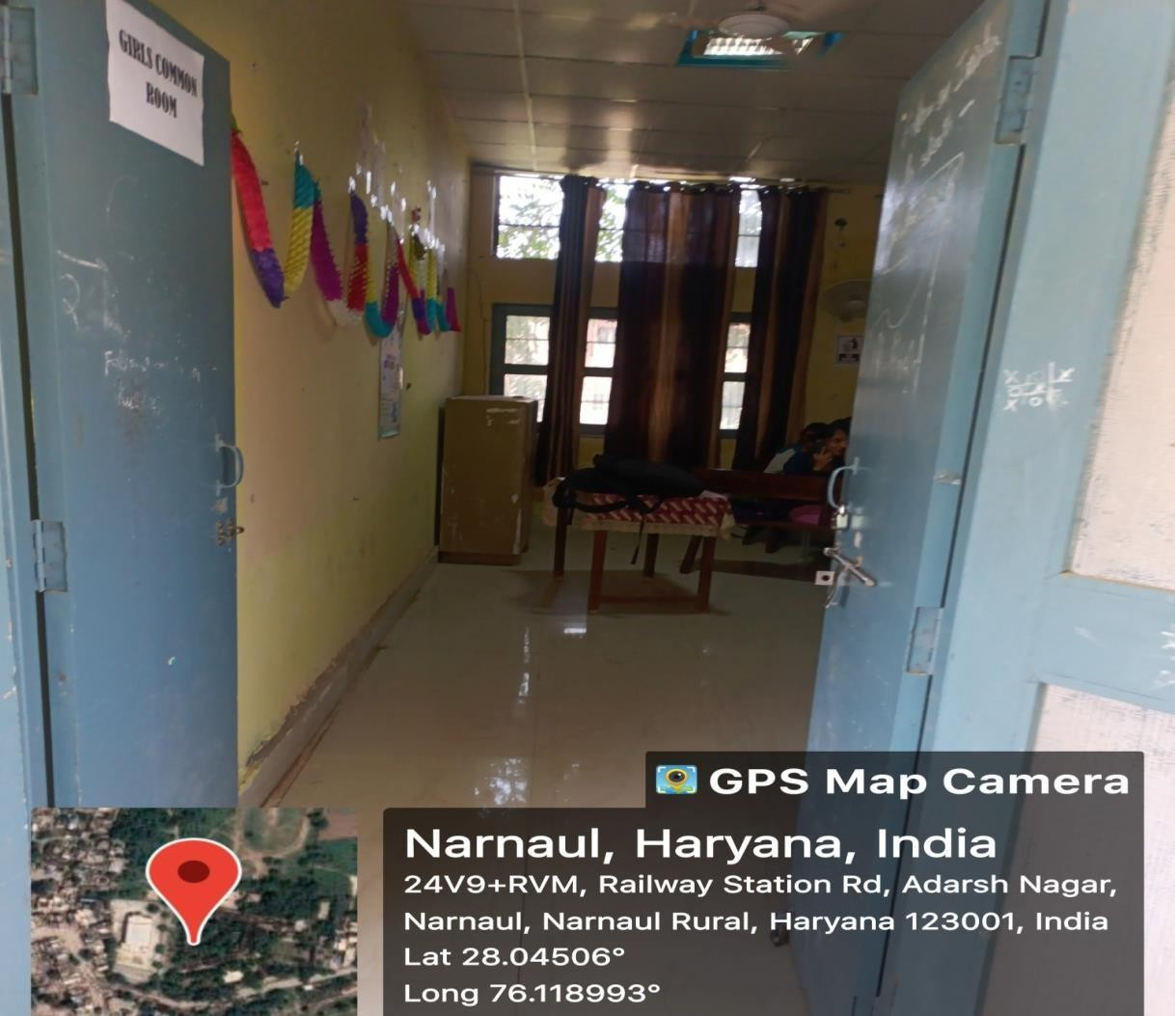

**Common Rooms for girls**

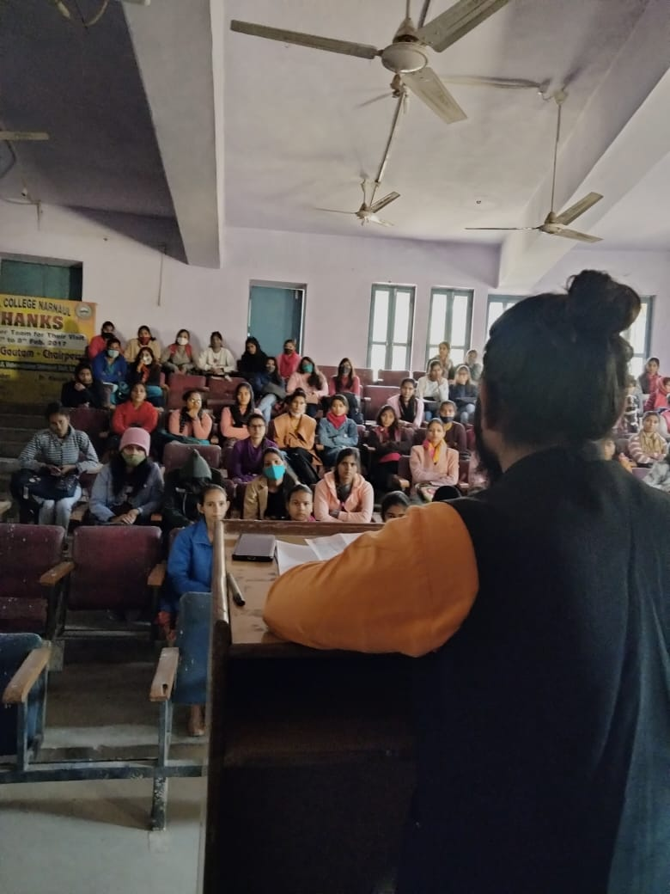

**Counselling**

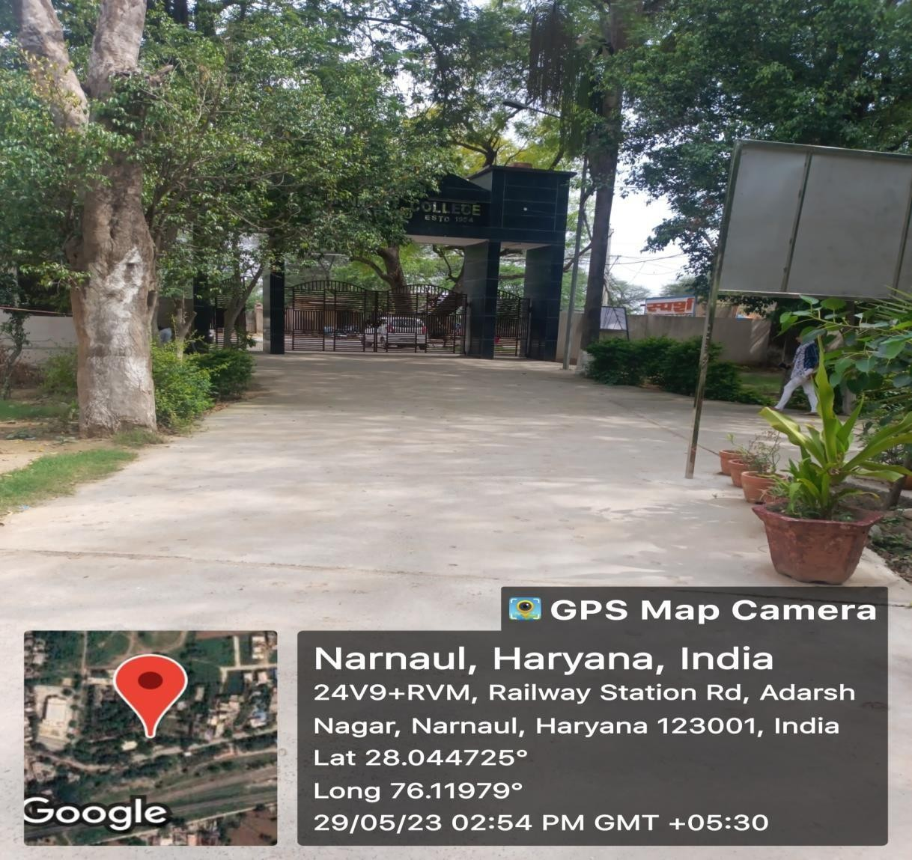

**Security Gate for the Girl**

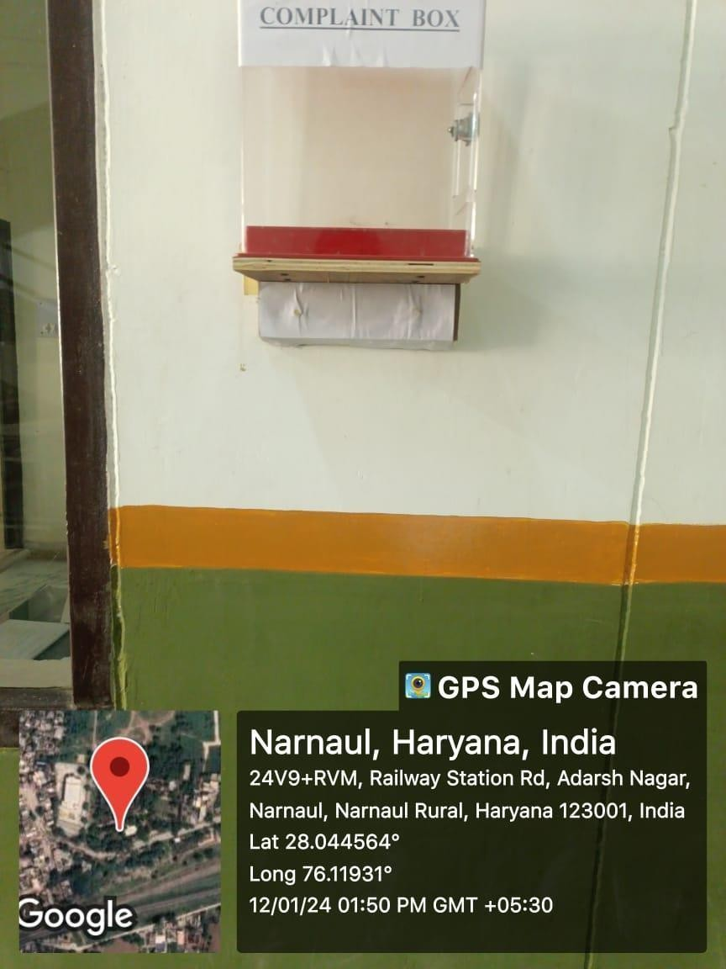

# Complain Box Installed in the Campus for any Grievance

Gender equity programmes –

Sports Meet for both girls & boys

Common classroom ,common workplace for both gender without any discrimination

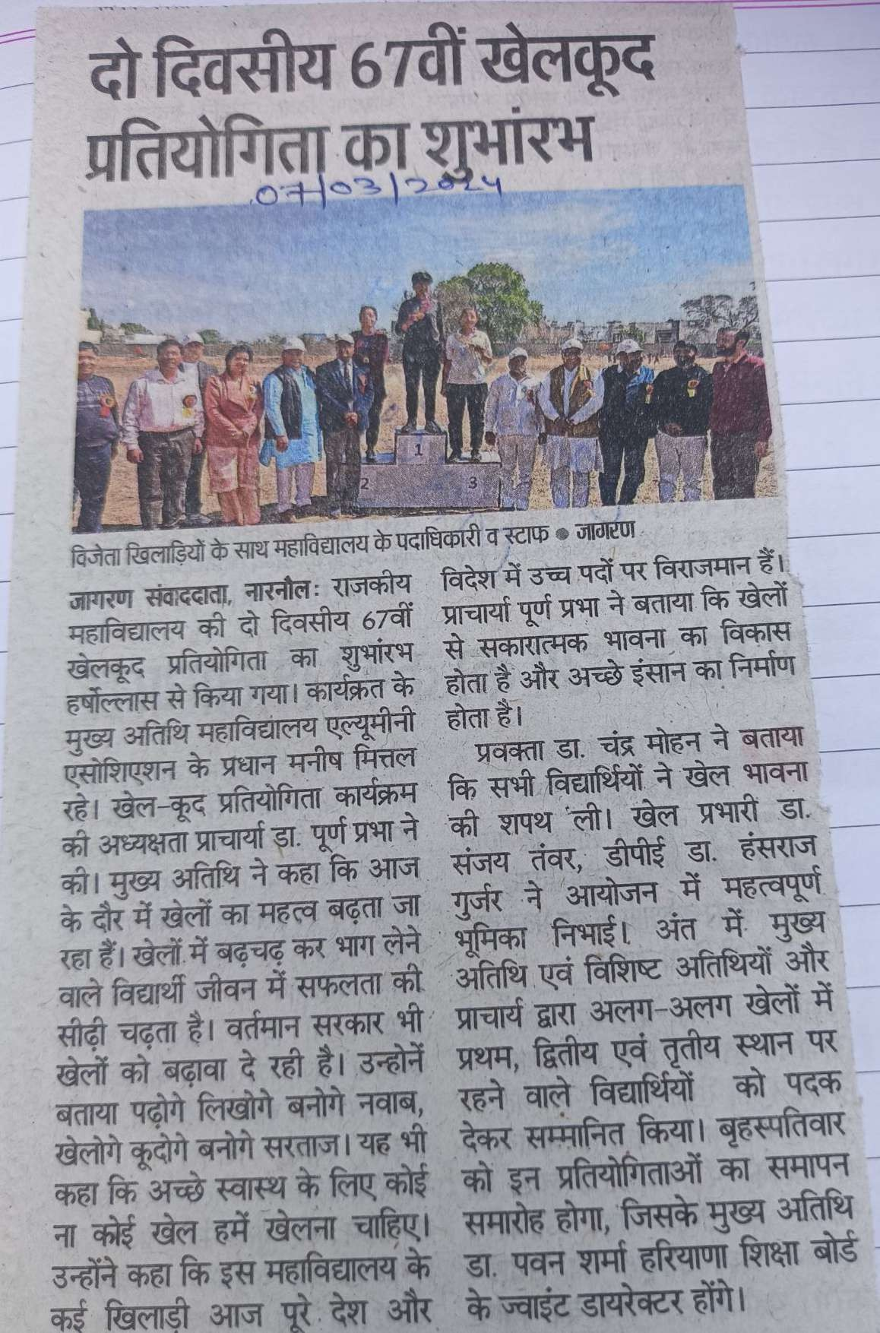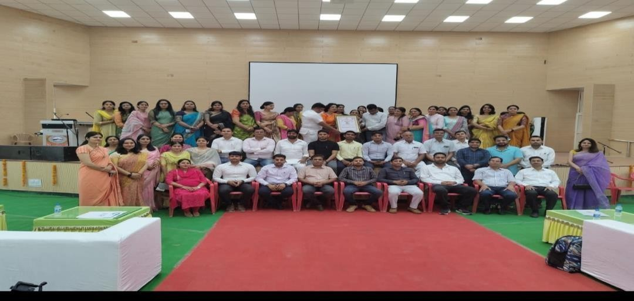

# Women empowerment programme by women development cell

# Gender Equity and Gender Sensitization programme by NSS

# Gender Equity and Gender Sensitization programme by NCC

# Gender Equity and Gender Sensitization programme by Sports Club

# Gender Equity and Gender Sensitization programme by Subject Socities

**Supporting Documents & programmes**

## Gender Sensitization and Gender Equity Programme

|  |  |  |  |  |
| --- | --- | --- | --- | --- |
| Session | Organising Unit | Activity Name | Date | |
| 2023-24 | WDC | Participation in Mission Sahasi (Self defence Mega Event | 2-11-2023 | |
| 2023-24 | WDC,NSS,NCC | Poster making competition & seminar on International Women’s Day | 08-03-2024 | |
| 2023-24 | WDC | Self Defence And Taek Wondo Workshop for ten days | 02-02-20 | 24 to 12-02-2024 |
|  | |
| 2023-24 | WDC | Poshan Pakhwada | (09-03-2024 to 23-03-  2024) | |
| 2023-24 | Management Deptt. | Don’t Abuse Women Programme | 2023-24 | |







E-mail - [principal.gcnnl@gmail.com](mailto:principal.gcnnl@gmail.com)

### Participation in Mission Sahasi (Self defence Mega Event organised by Women Cell, IGU,





E-mail - [principal.gcnnl@gmail.com](mailto:principal.gcnnl@gmail.com)

### International Women’s Day (08-03-2024)

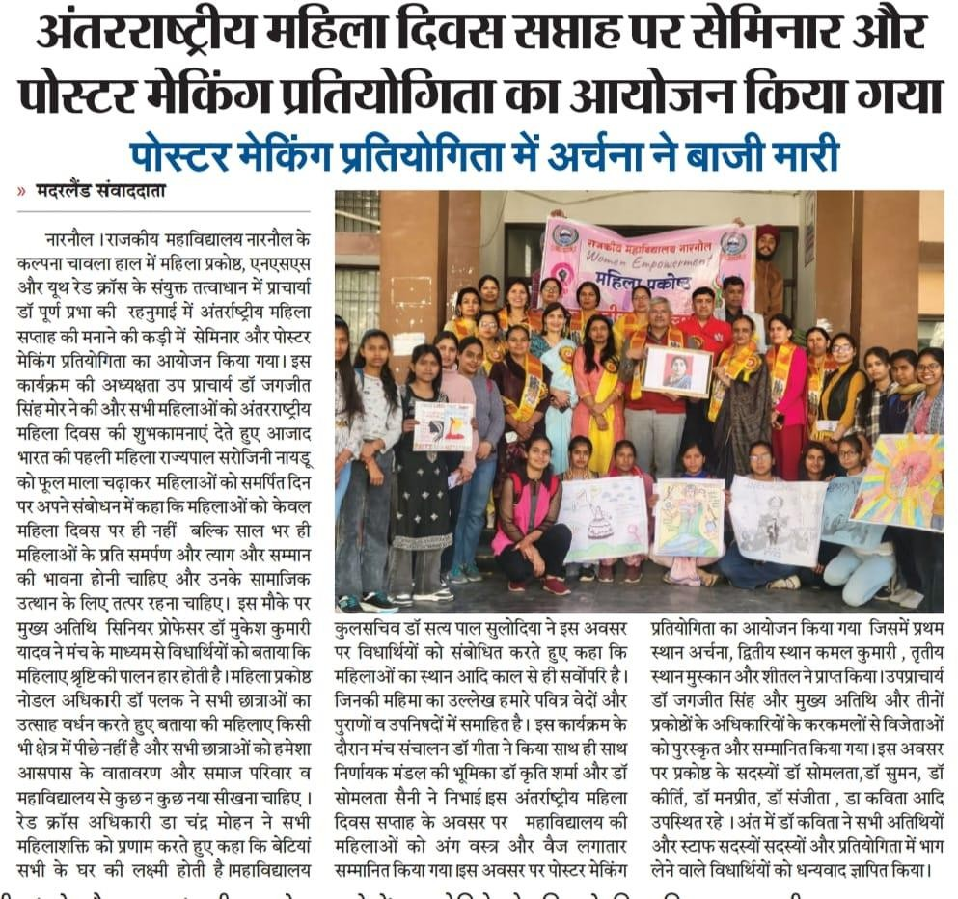





E-mail - [principal.gcnnl@gmail.com](mailto:principal.gcnnl@gmail.com)

### Self Defence And Taek Wondo Workshop for ten days, organized by Women Development

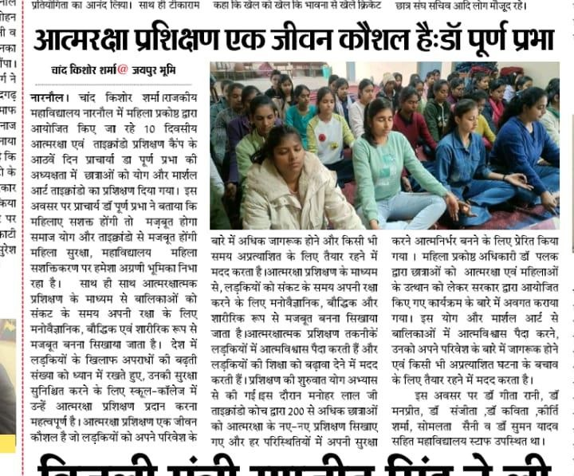





E-mail - [principal.gcnnl@gmail.com](mailto:principal.gcnnl@gmail.com)

### Poshan Pakhwada (09-03-2024 to 23-03-2024)

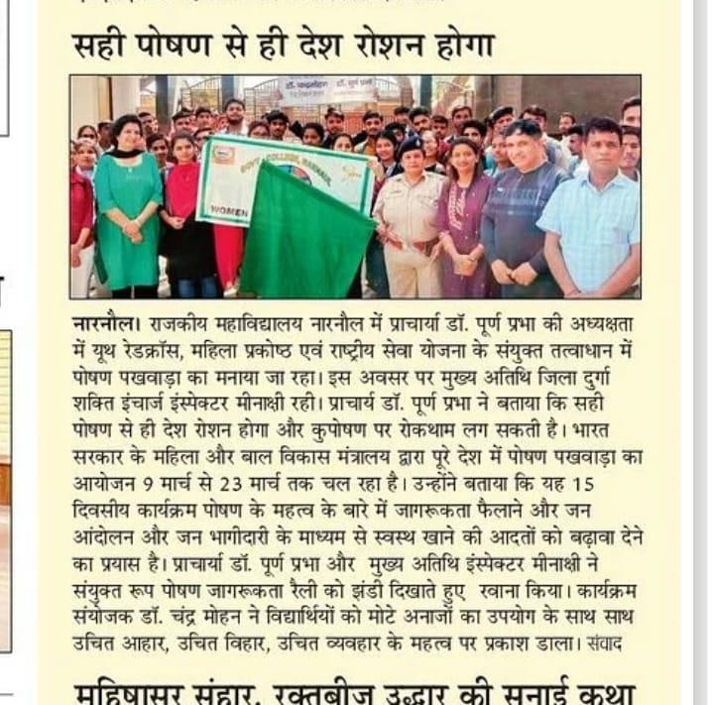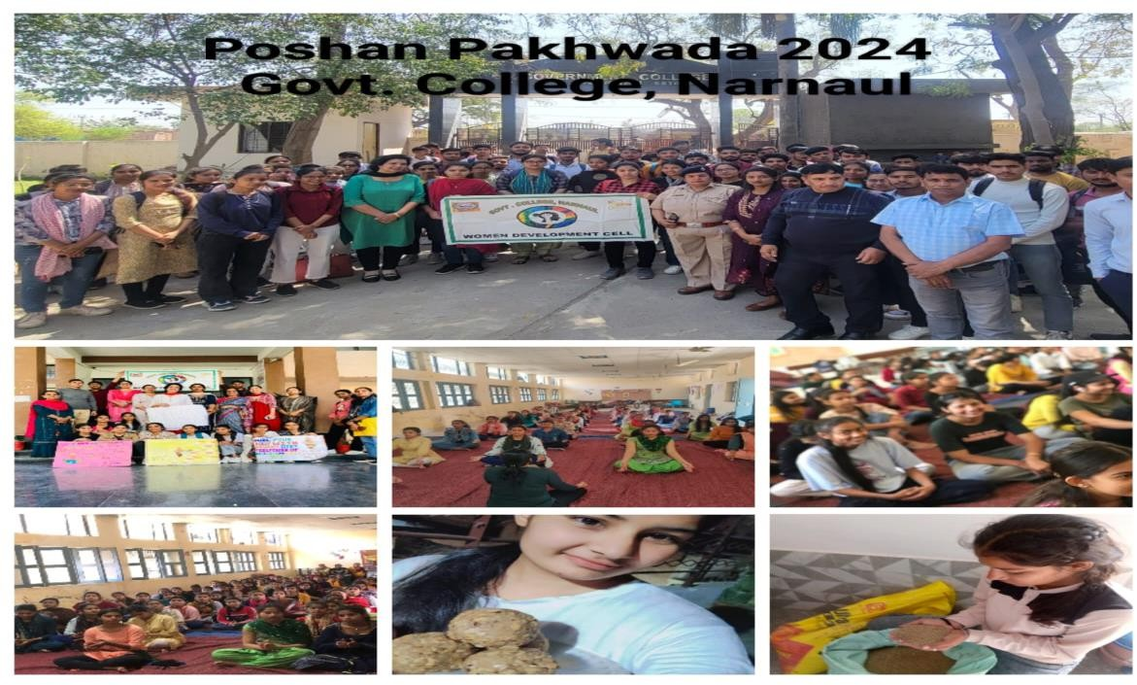





E-mail - [principal.gcnnl@gmail.com](mailto:principal.gcnnl@gmail.com)

