**OFFICE OF THE PRINCIPAL**

**GOVERNMENT COLLEGE NARNAUL**

**SUPPORTING DOCUMENTS FOR 7.1.3**

**FACILITIES IN THE INSTITUTION FOR THE MANAGEMENT OF DEGRADABLE AND NONDEGRADABLE WASTE**

**Solid Waste Management:**

* Dustbins are provided on the campus to keep the campus clean, neat and tidy.
* There are various dustbins on the college campus, i.e., corridors, lawns, washrooms, etc.
* Awareness of waste segregation in created blue-green and red dustbins are used. Arrangements are made for solid waste management.
* Compost arrangements are also made to cover solid waste into fertilizer. The Sanitary Napkin Machine is installed in women cell.
* Students and staff members are advised to put the waste material in the dustbins.

**Liquid Waste Management:**

* Our college manages the proper system of liquid waste.
* Liquid waste from toilets is drained through the municipal main drain
* Liquid waste from the points of generation, like the toilet, kitchen, etc.,is let out efficiently into a proper drainage facility.
* The entire used sewage, washing, and drinking water are adequately managed.

**E-Waste Management:**

* All e-waste is disposed to a separate room.



* Non-functional computer equipment and its peripherals are safely disposed of. The cartridge of the laser printer is refilled outside the college campus.
* UPS batteries are recharged/repaired by the supporting instrument or photo linked. The laboratory assistants and teaching staff set minor repairs.
* E-waste is generated using obsolete computer systems, including monitors and CPUs.



**Principal**

**Govt. College Narnaul**

**This document contains information regarding-**

* **Efforts towards Solid Waste Management**
* **Efforts towards Liquid Waste Management**
* **Efforts towards E-Waste Management**

**EFFORTS TOWARDS SOLID WASTE MANAGEMENT**

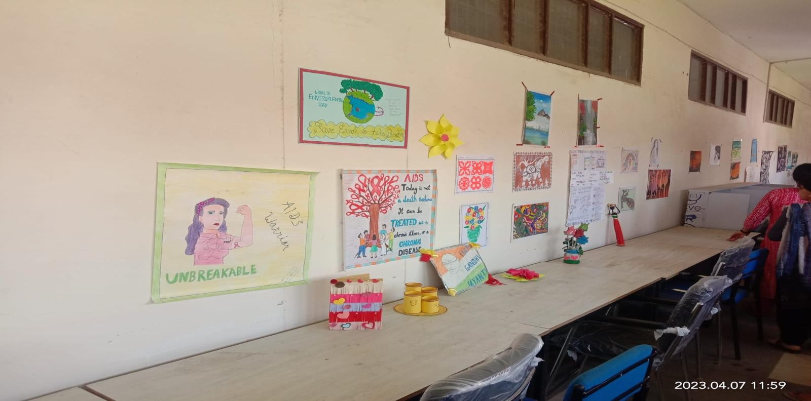

**Art about making use from waste**

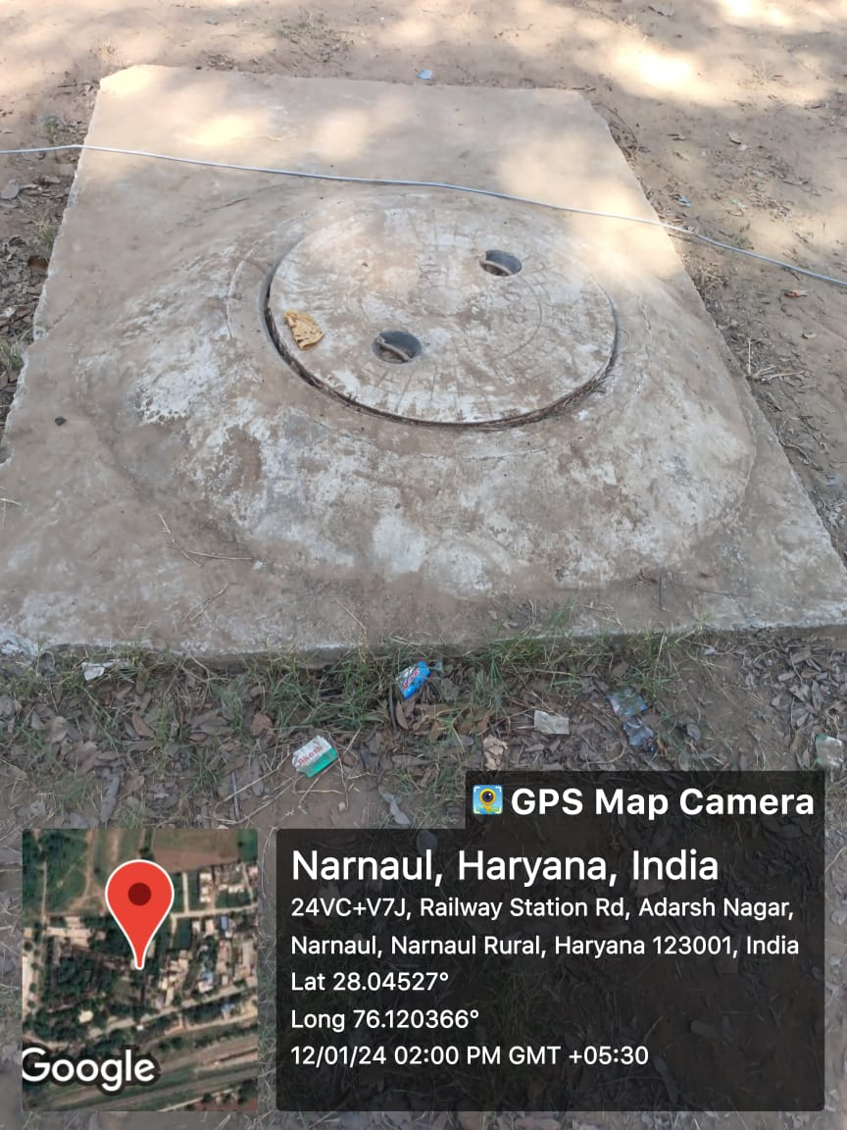

**Block of Sewerage**

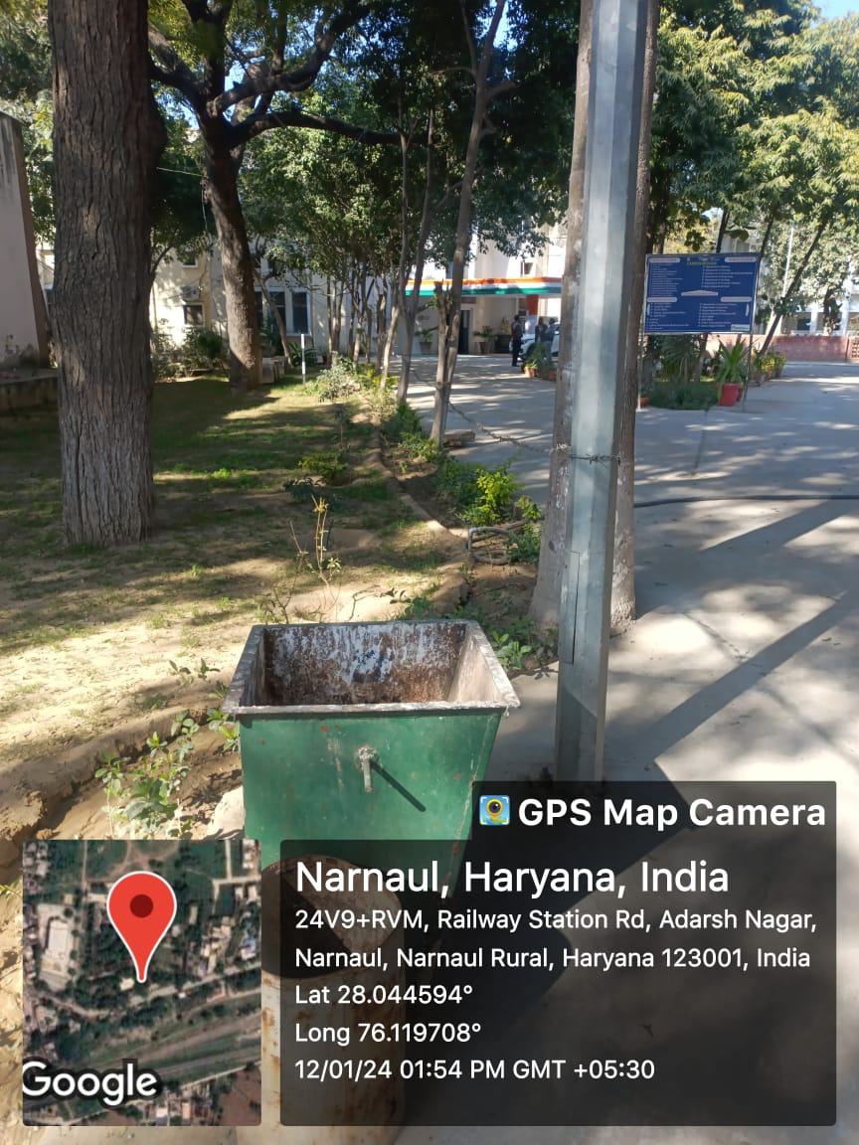

**Dustbin**

**PHOTOGRAPHS OF RAIN WATER HARVESTING / BOREWELL / TANKS**

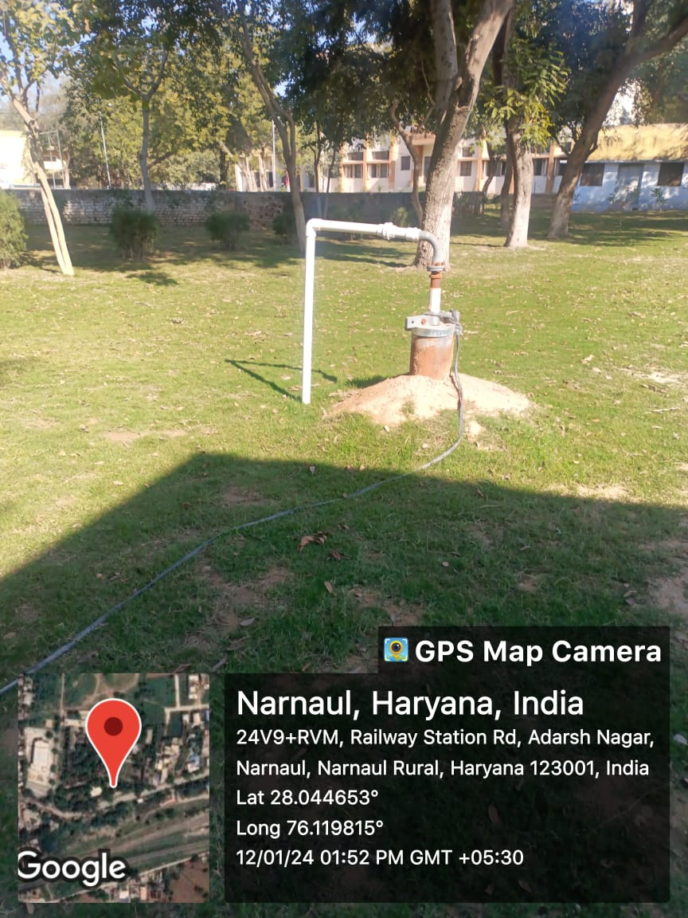 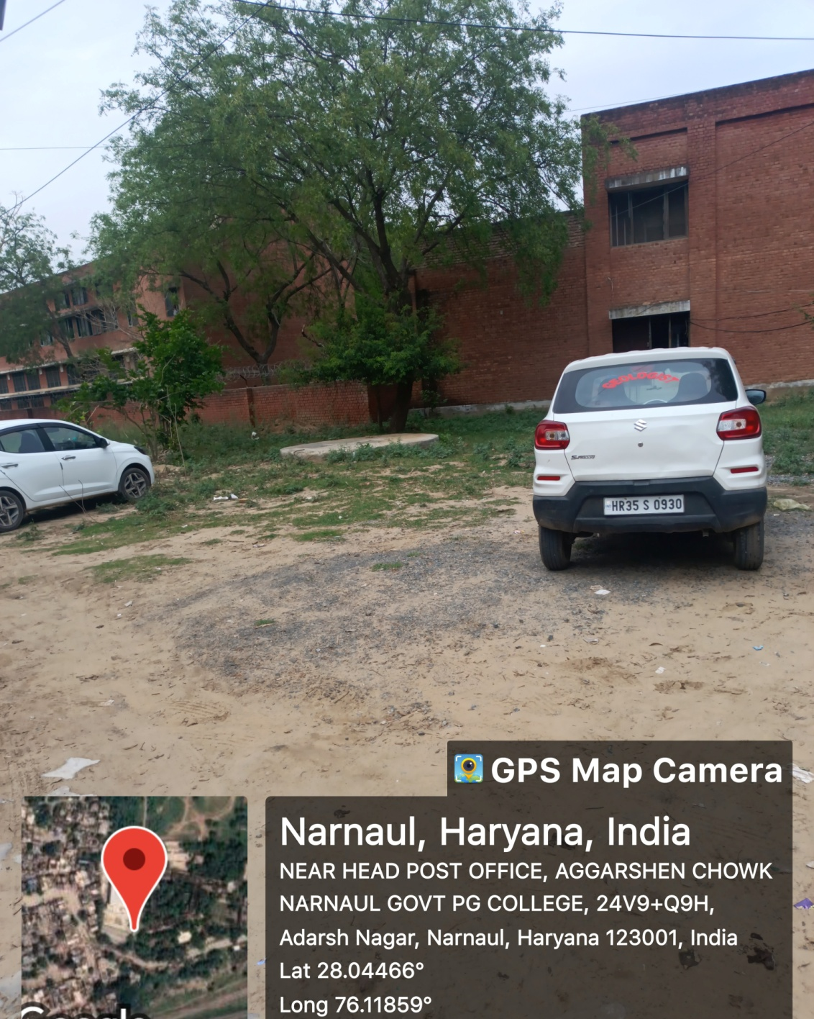

**Borewell Rain Water Harvesting**

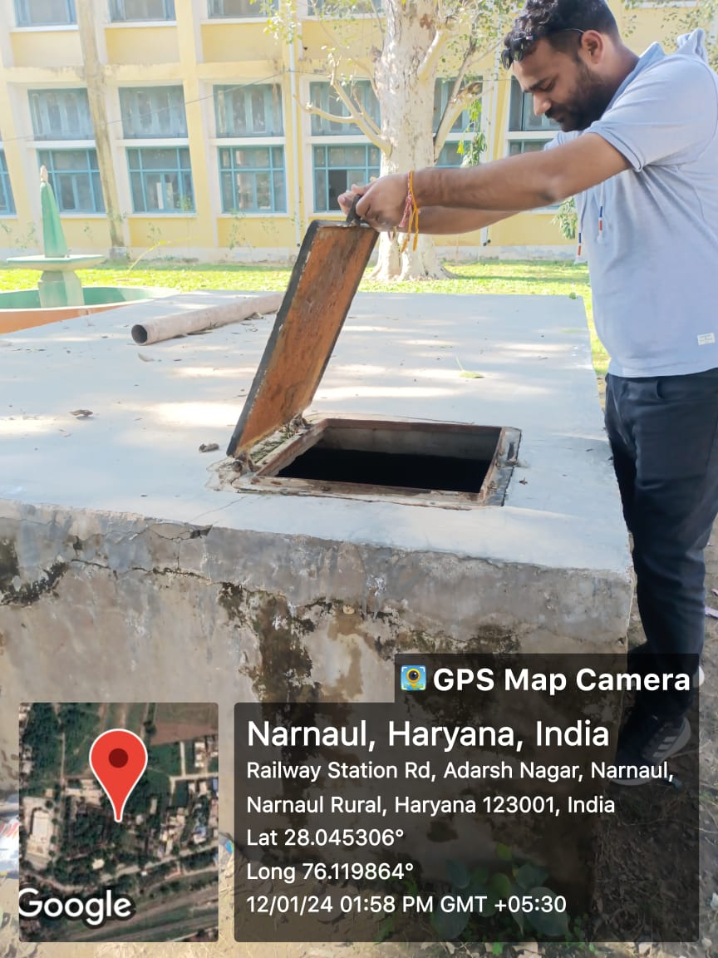

**Water Storage Tank**