**OFFICE OF THE PRINCIPAL**

**GOVERNMENT COLLEGE NARNAUL**

**SUPPORTING DOCUMENTS FOR 7.1.8**

***Describe the Institutional efforts/initiatives in providing an inclusive environment i.e., tolerance and harmony towards cultural, regional, linguistic, communal socioeconomic and other diversities (within 200 words).***

College is undertaking initiatives for an inclusive environment and developing tolerance and harmony.

Following activities are undertaken:

1.Exposure to diverse cultural traditions through various societies activities including Arts and Indian Folk Dance, Indian Music, and Indian classical. Cultural society raises awareness about our Cultural traditions.

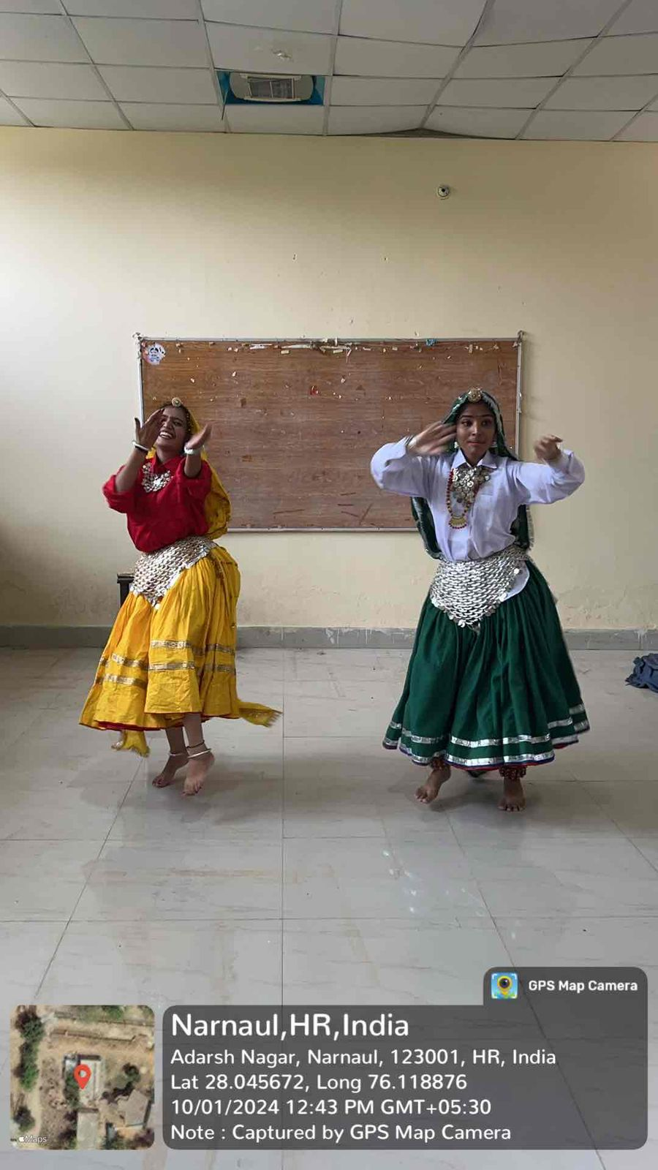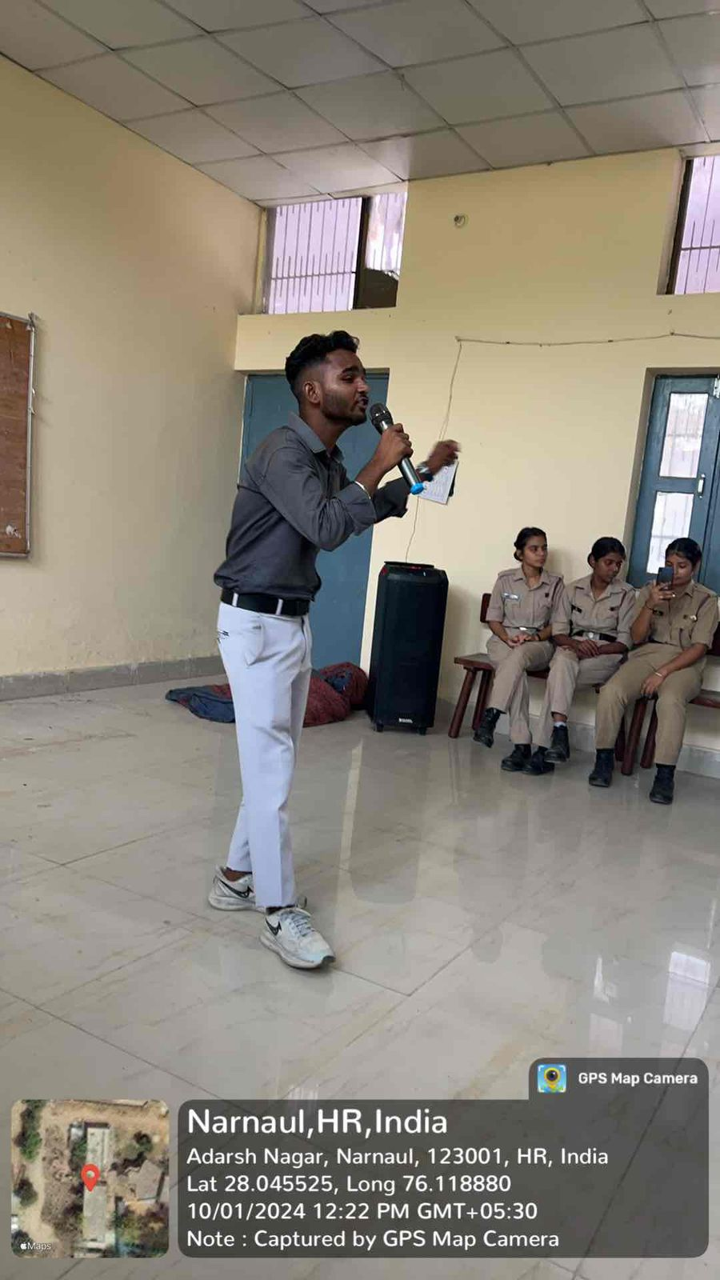

2. Focus on linguistic diversity: Besides Hindi, English, and Sanskrit is also taught and activities undertaken in all languages.

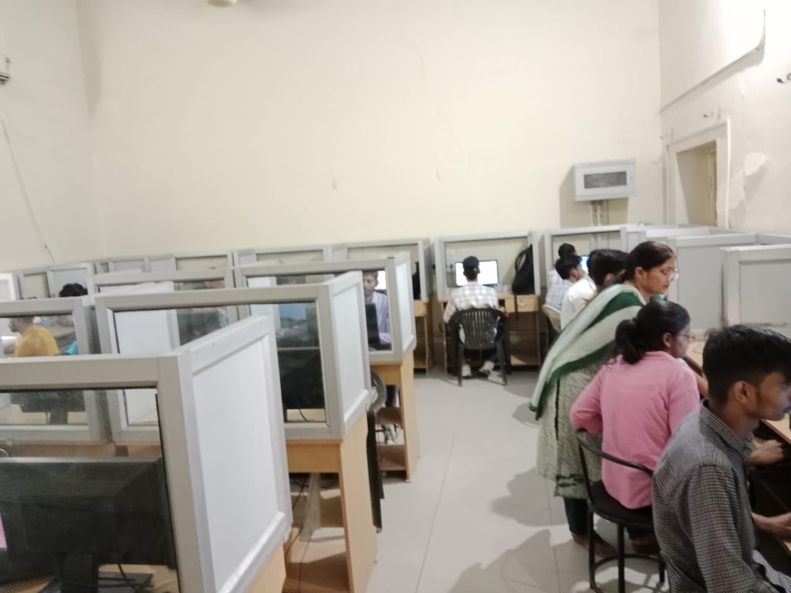

3. College publications etc. to promote inclusiveness and appreciate linguistic diversity.



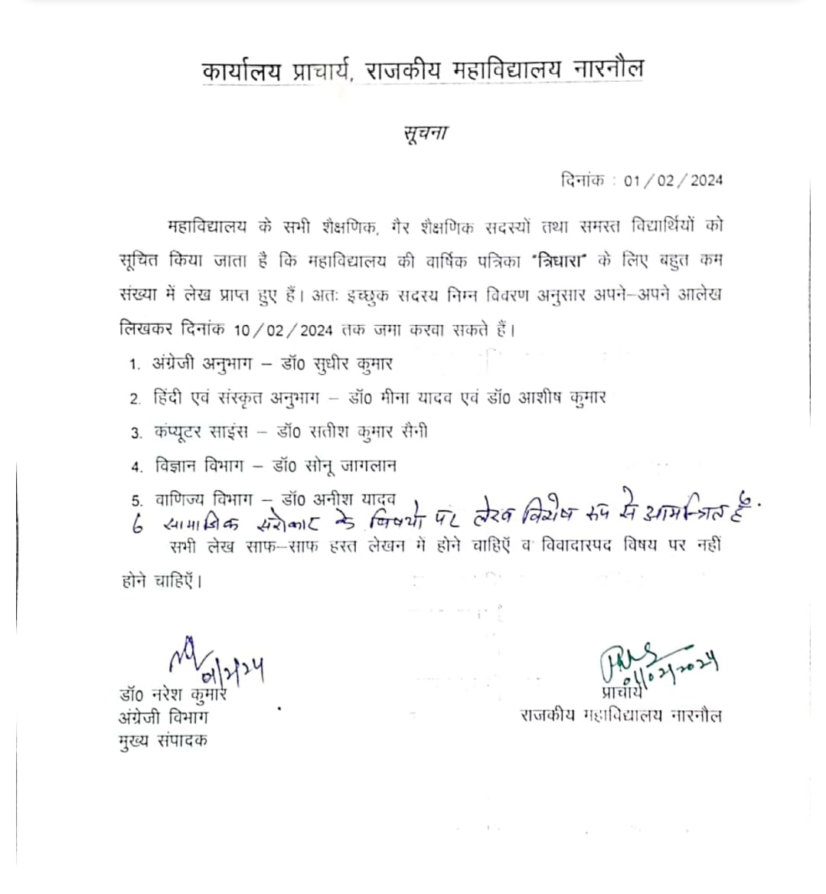

4. NSS activities emphasizing inclusiveness: For underprivileged families in slums educational initiative.



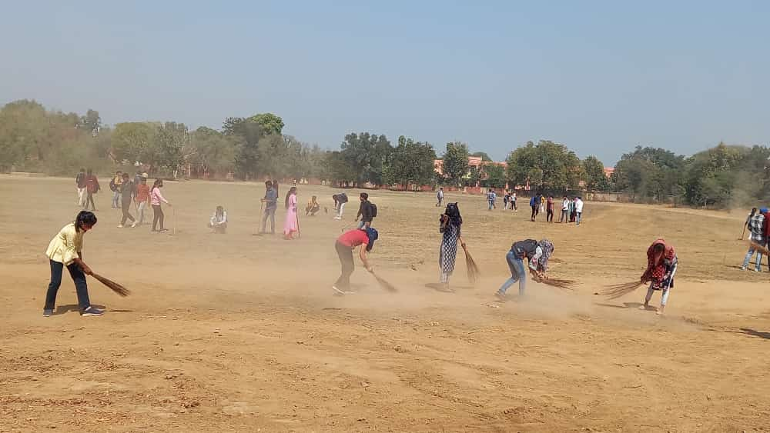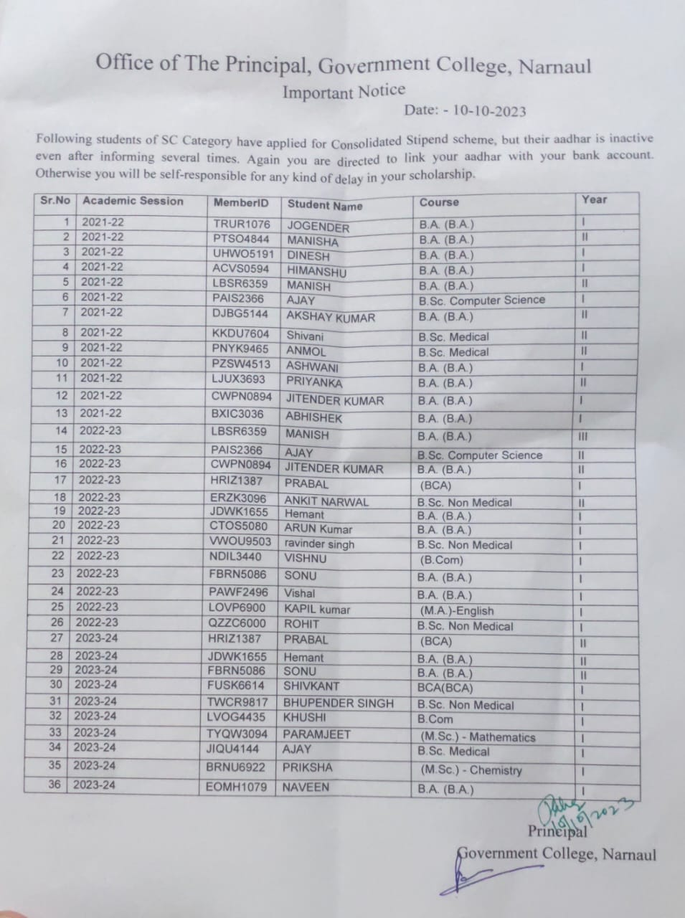

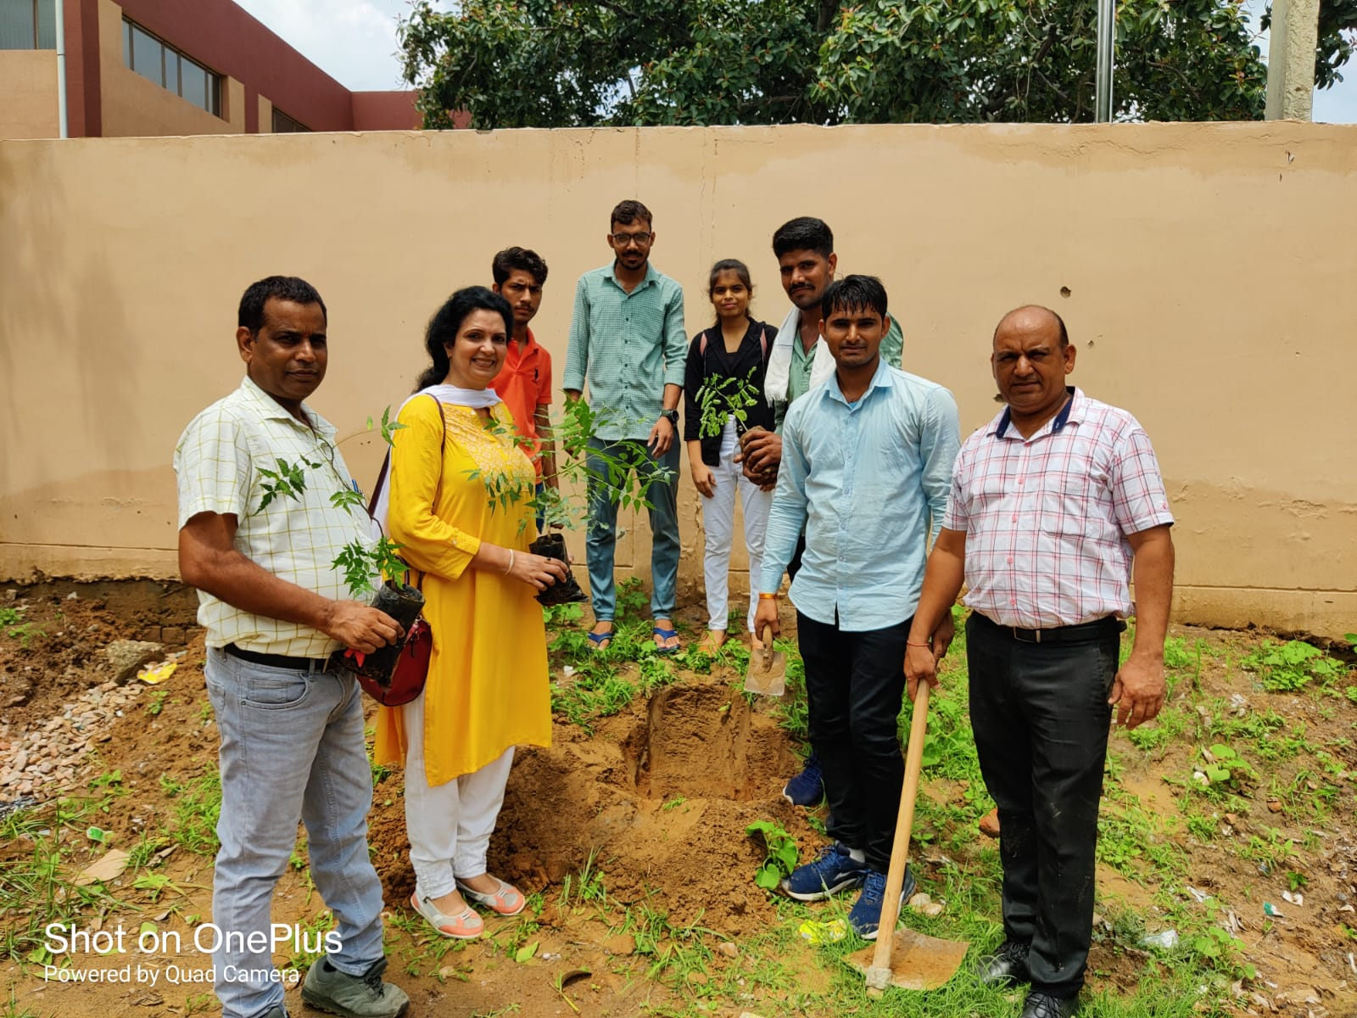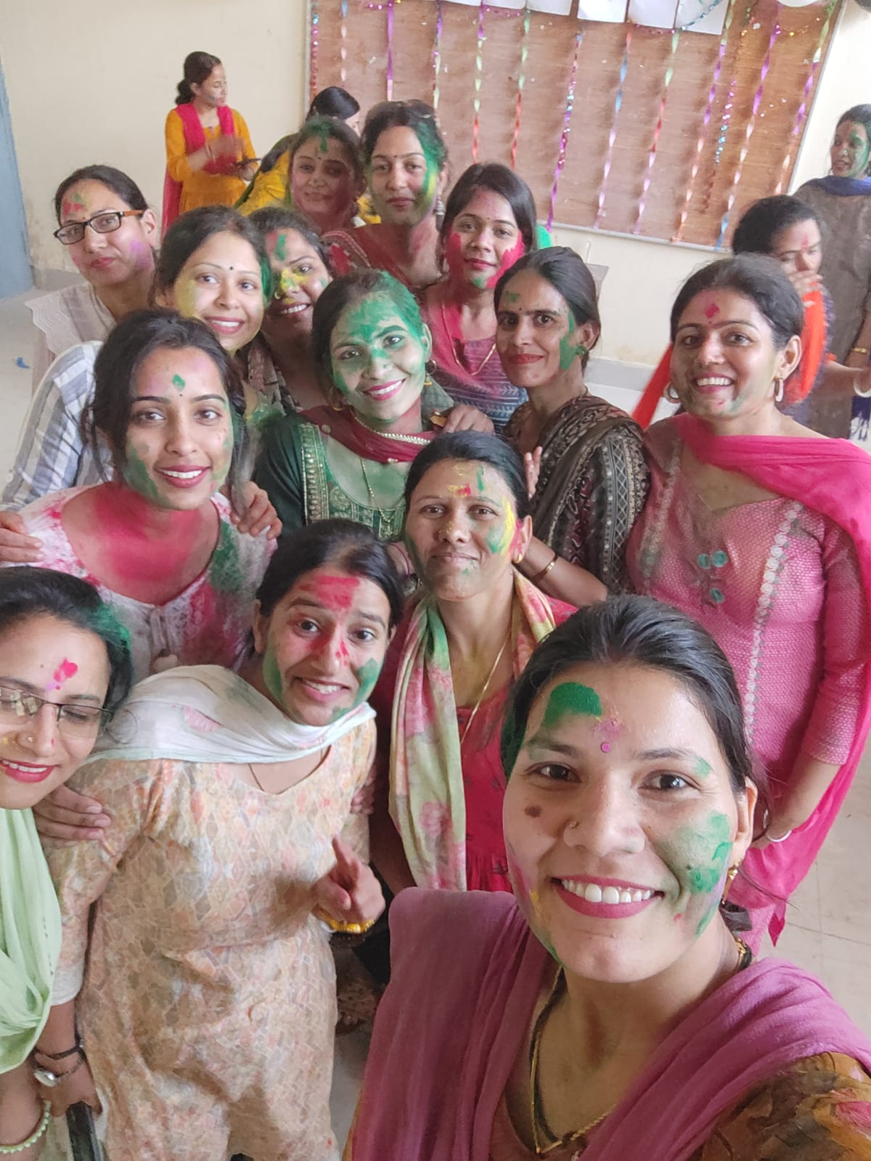

5. Tolerance and armony promoted by specific committees cultural, sports committee through different activities.

6.Inclusive environment for PwD students: There are ramps, pathways designed for visually impaired and PwD friendly washrooms.

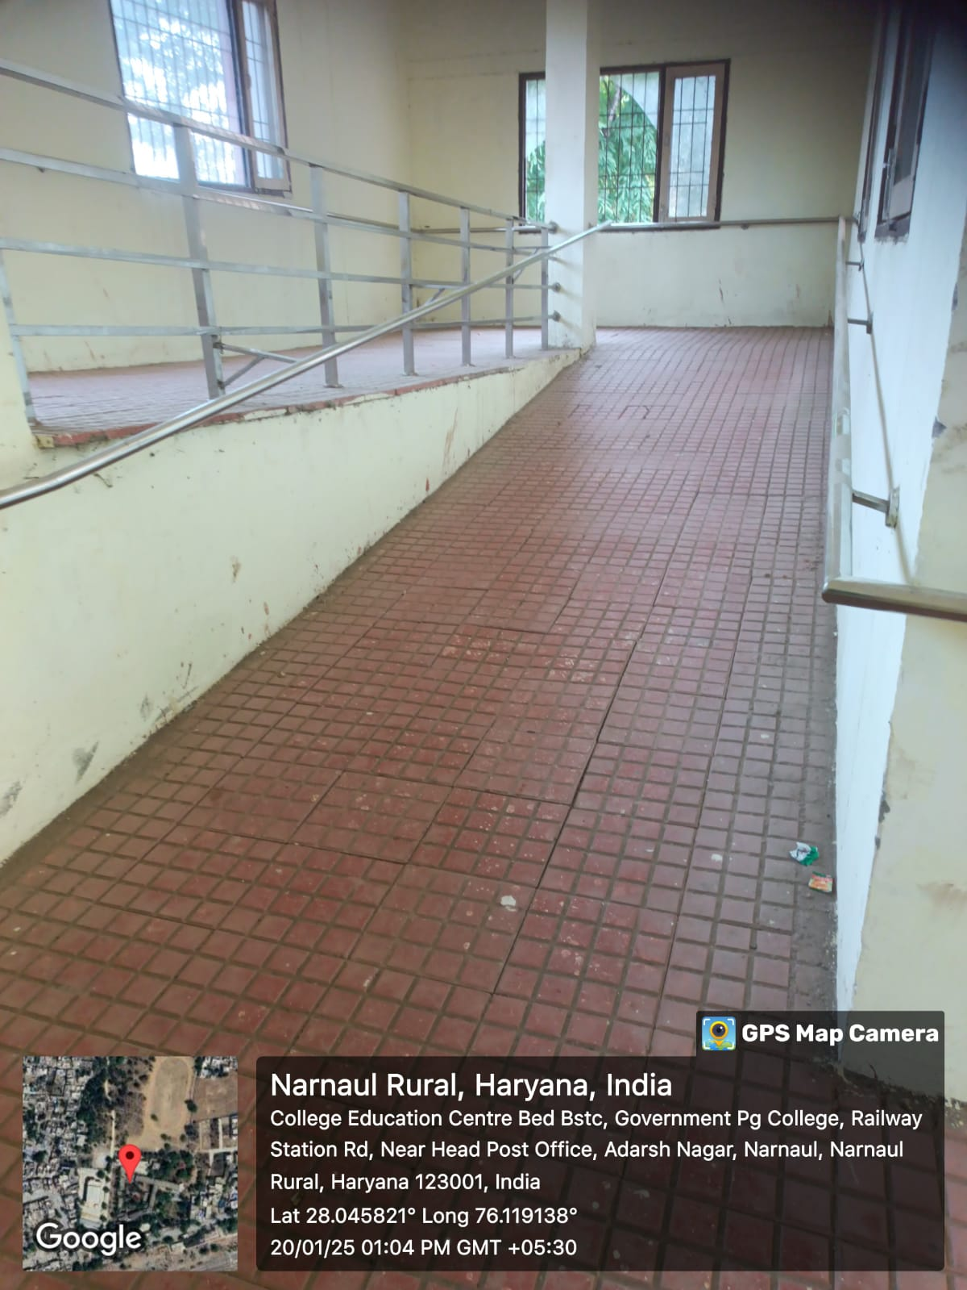

7. Enabling committee helps pierce the pre-established silence around stigmatized identity and through its timely intervention expands the structural boundaries of women’s education.

s 8.Some images of college atmosphere showing tolerance and harmony towards cultural, regional, linguistic, communal socioeconomic and other diversities. All students and staff members believe in unity irrespective of different diversities in their socio economic status religions ,regional, linguistic

