**OFFICE OF THE PRINCIPAL**

**GOVERNMENT COLLEGE NARNAUL**

**SUPPORTING DOCUMENTS FOR 7.1.9**

***Sensitization of students and employees of the Institution to the constitutional obligations: values, rights, duties and responsibilities of citizens***

**Azadi ka Amrit Mahotsav**

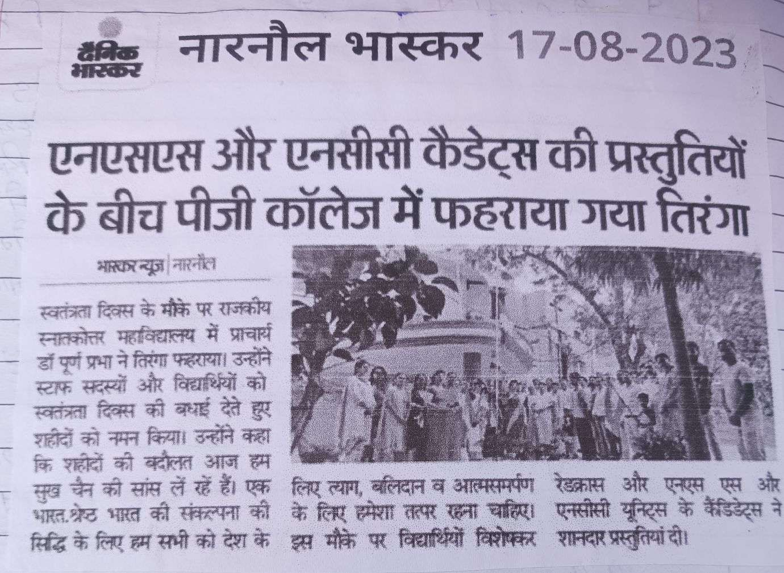

**Sensitizing yoga practices through National Yoga Day (21 June, 2023)**

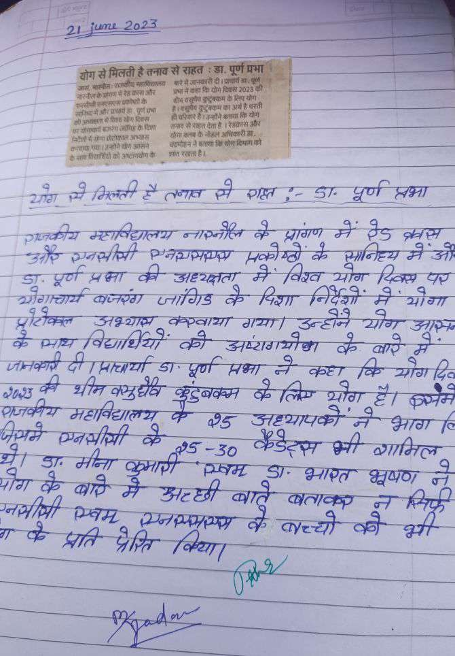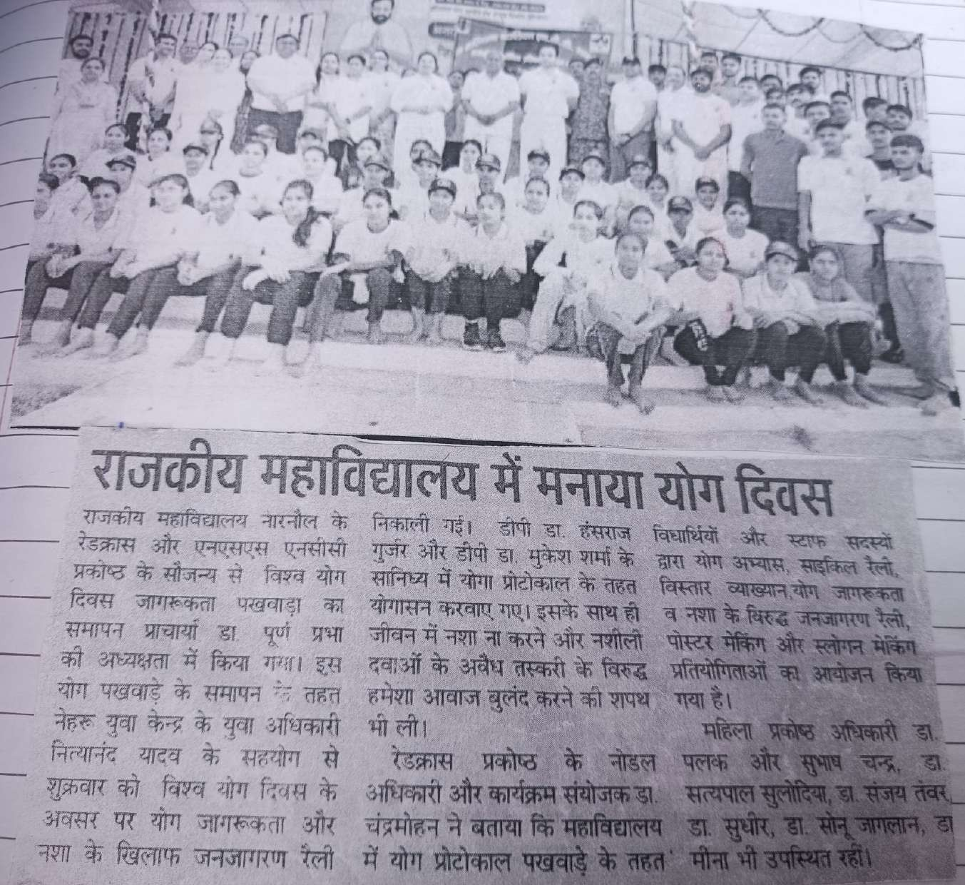

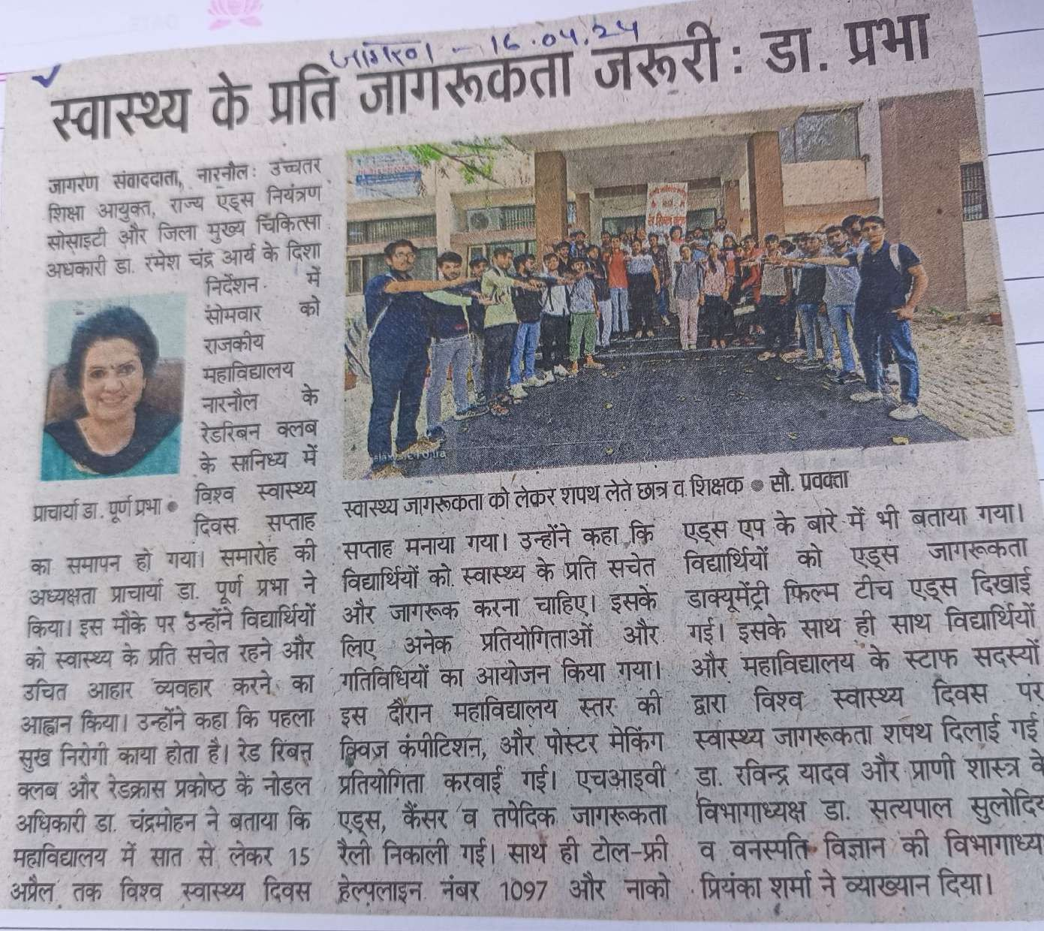

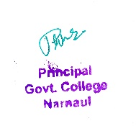

**Sensitizing for public health through World Health Day**

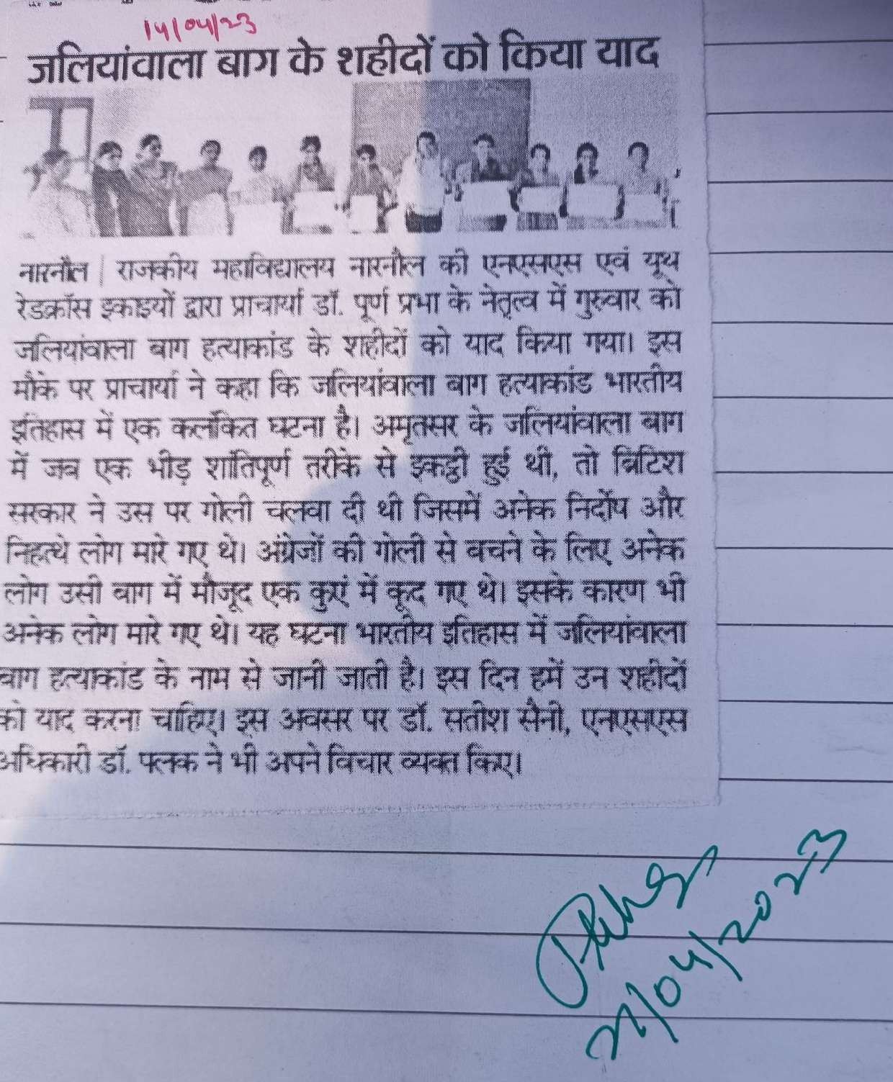

**Sensitizing through Jallianwala Bagh Massacre Day (13 April, 2024)**

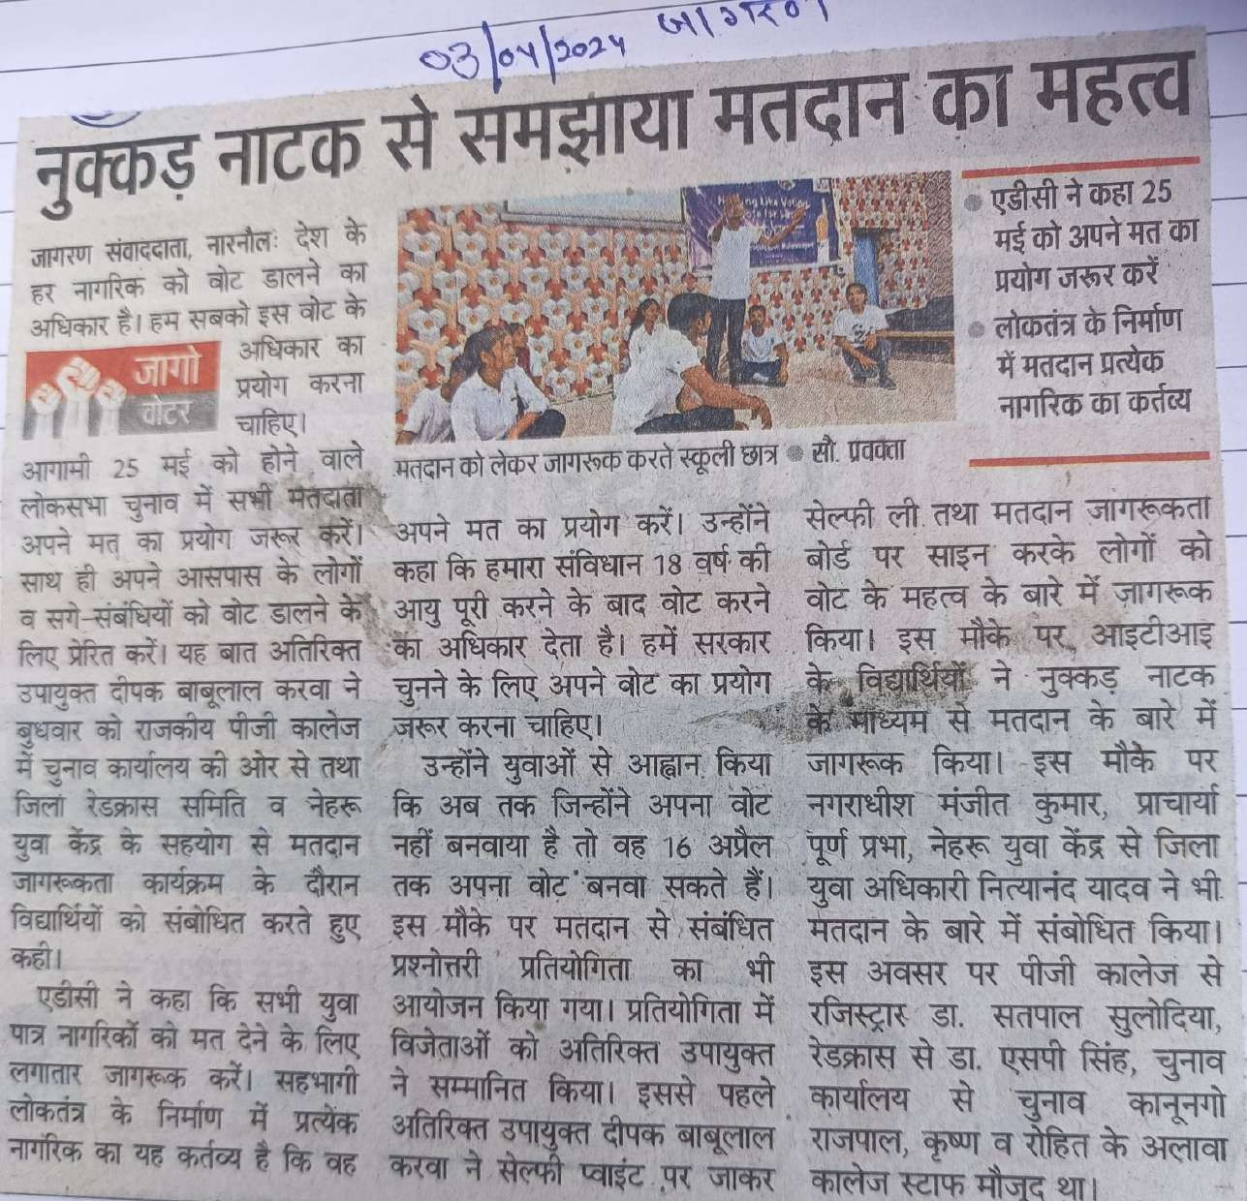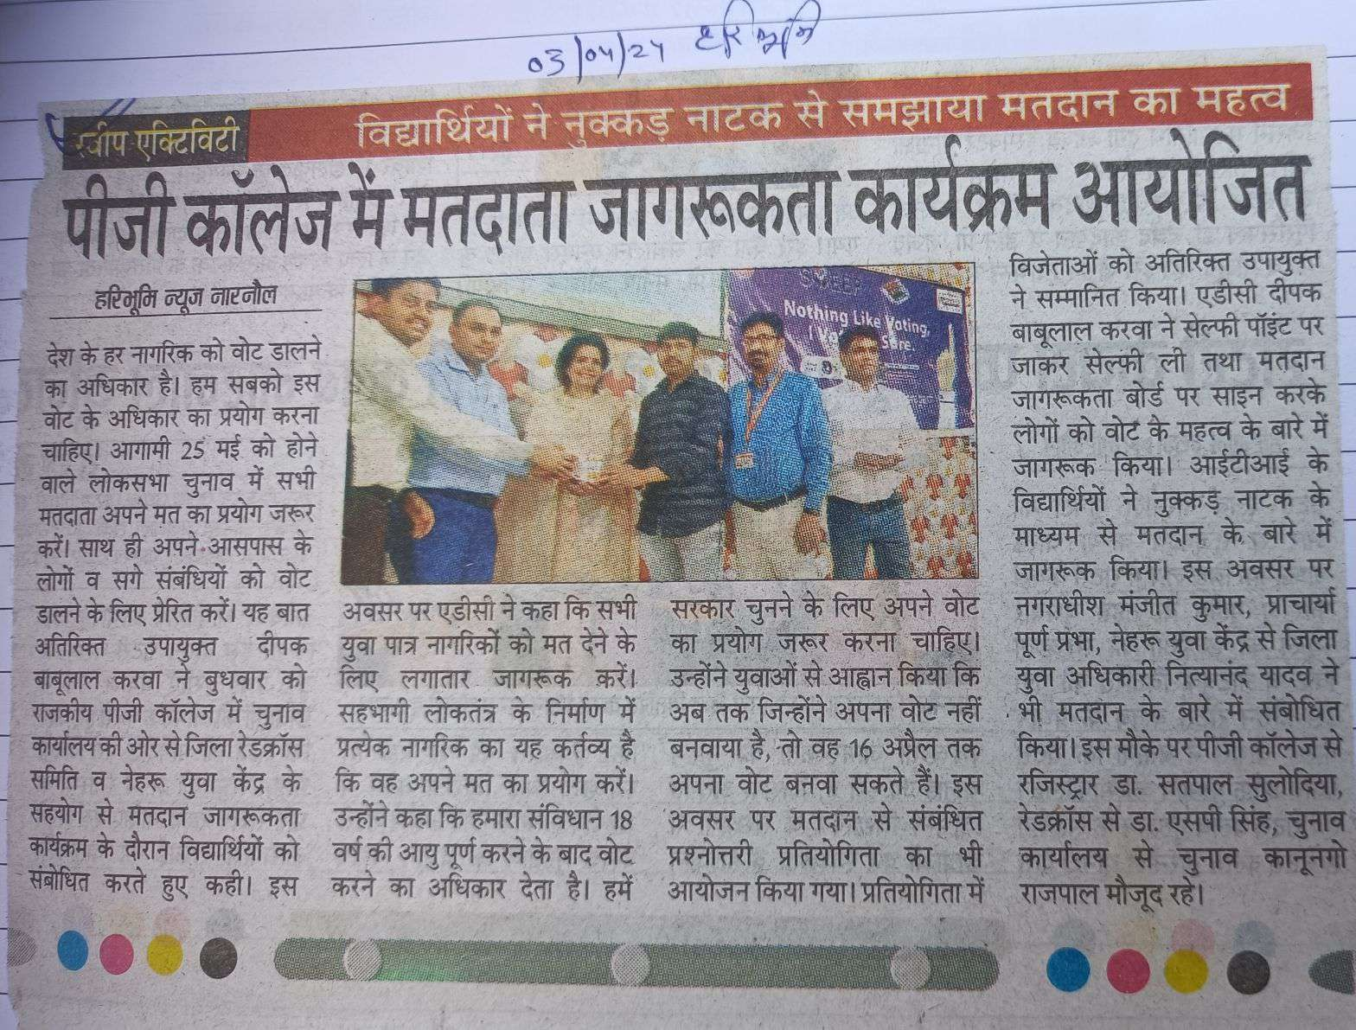

**Sensitizing through Voter Awareness Day**

**Sensitizing through Celebration of National Women’s Day**

**(Birth Anniversary on Smt. Sarojini Naidu ji )**

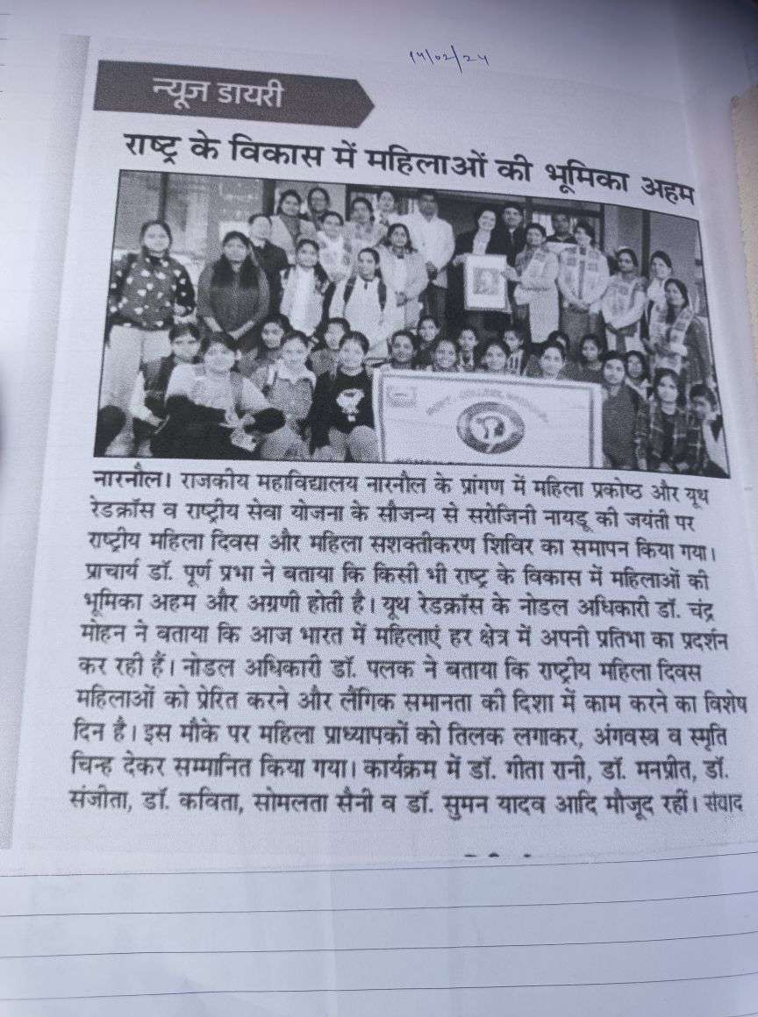

**Sensitizing through Celebration of Hindi Diwas Day**

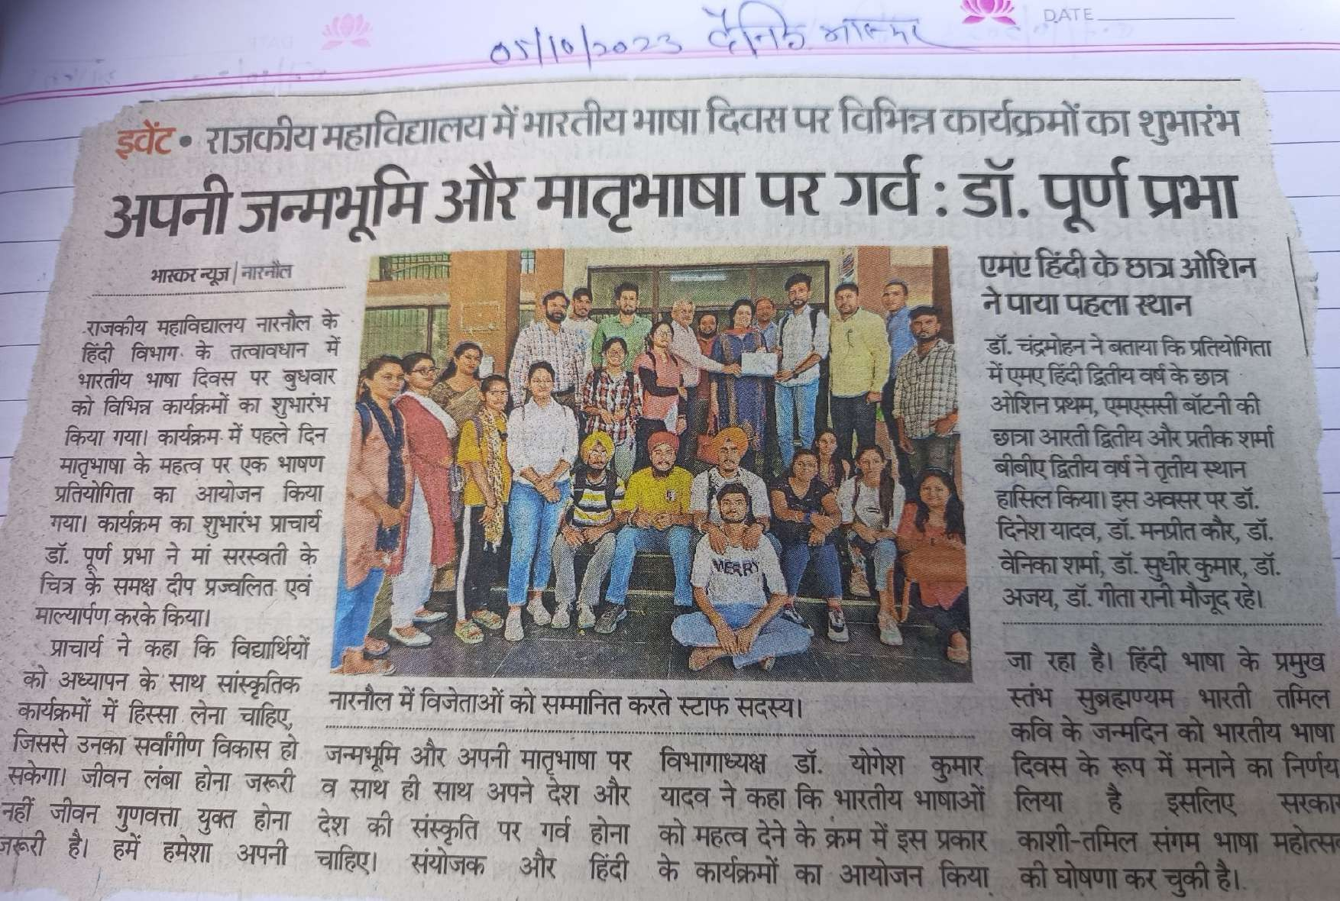

**Sensitizing through Celebration of Environment Day**

**Sensitizing through Celebration of World Aids Day**

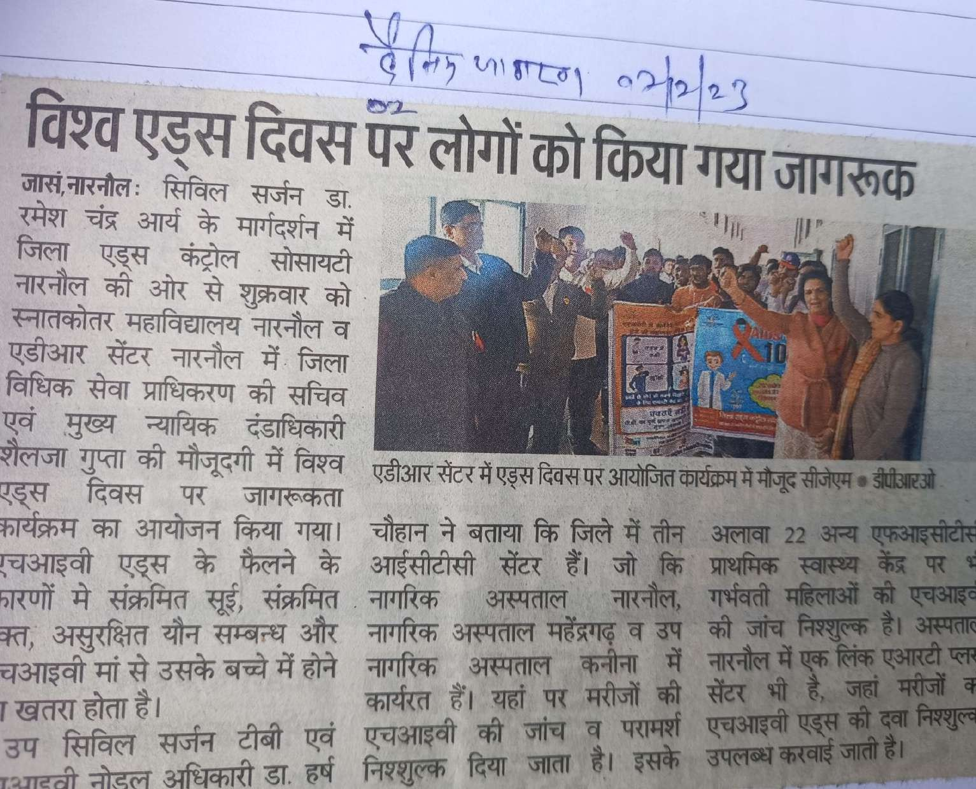

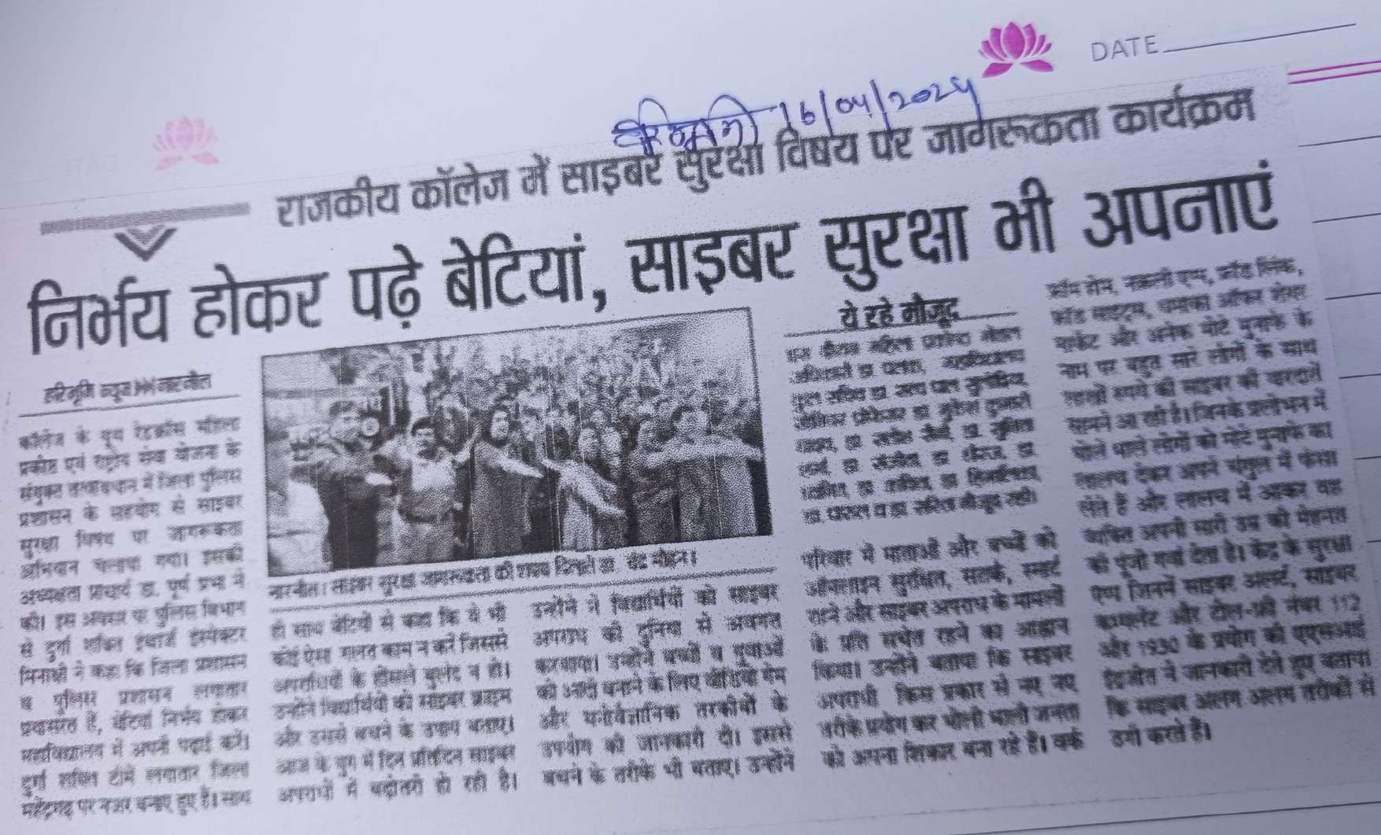

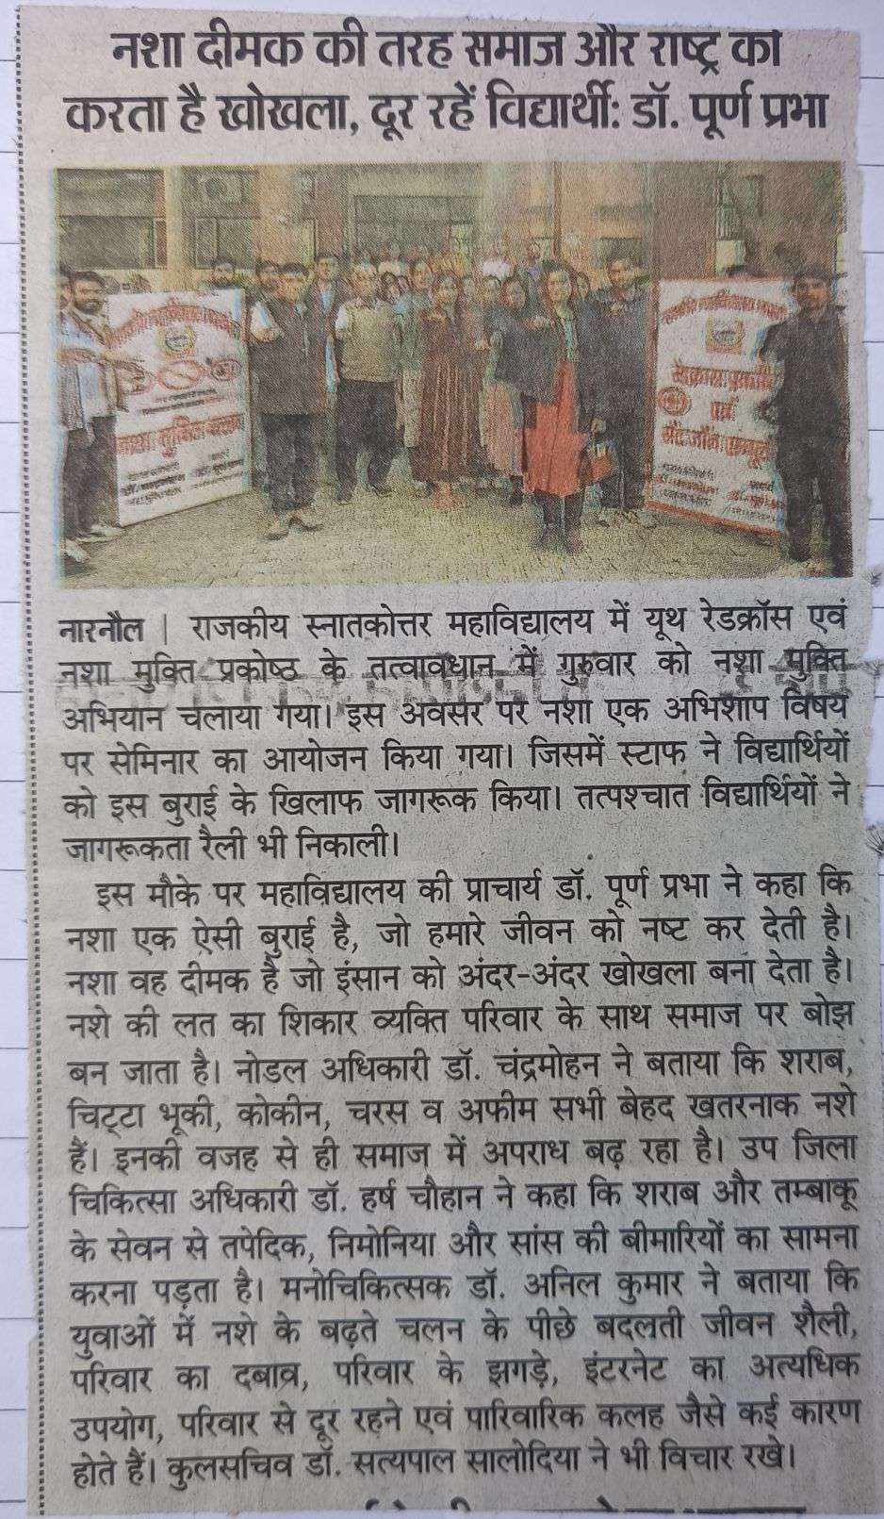

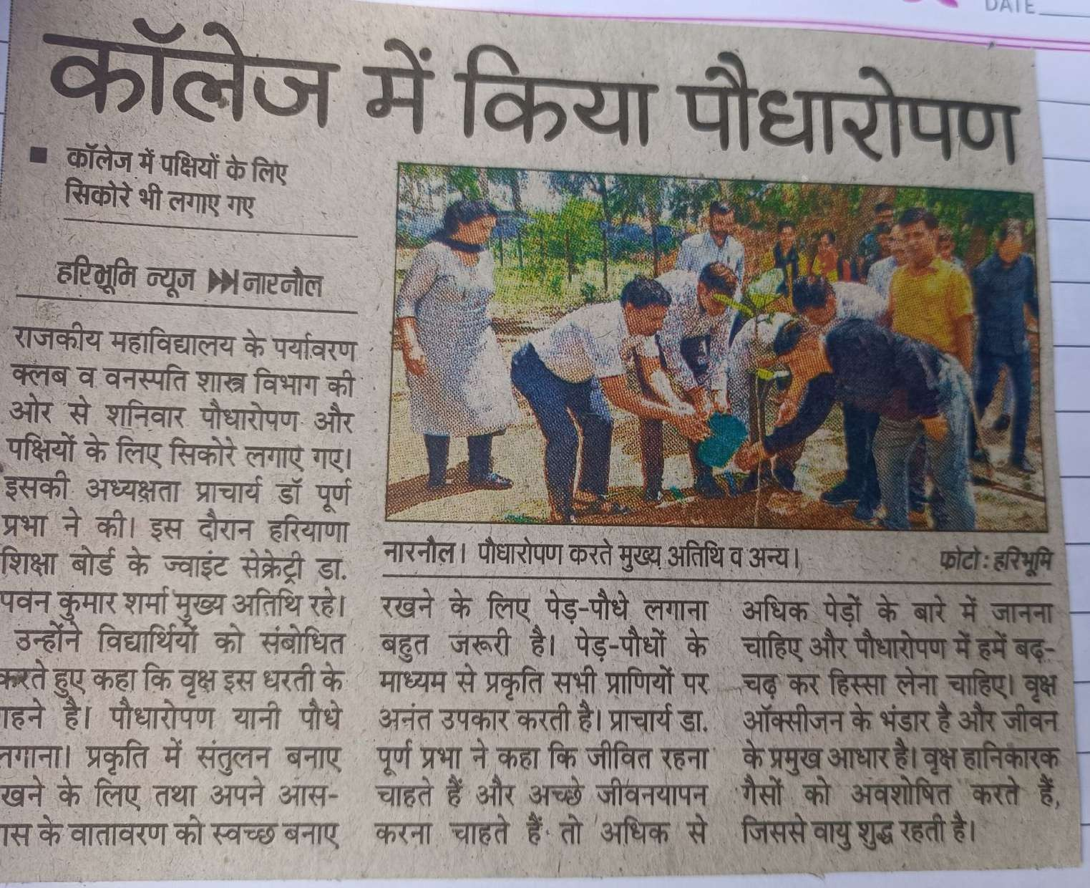

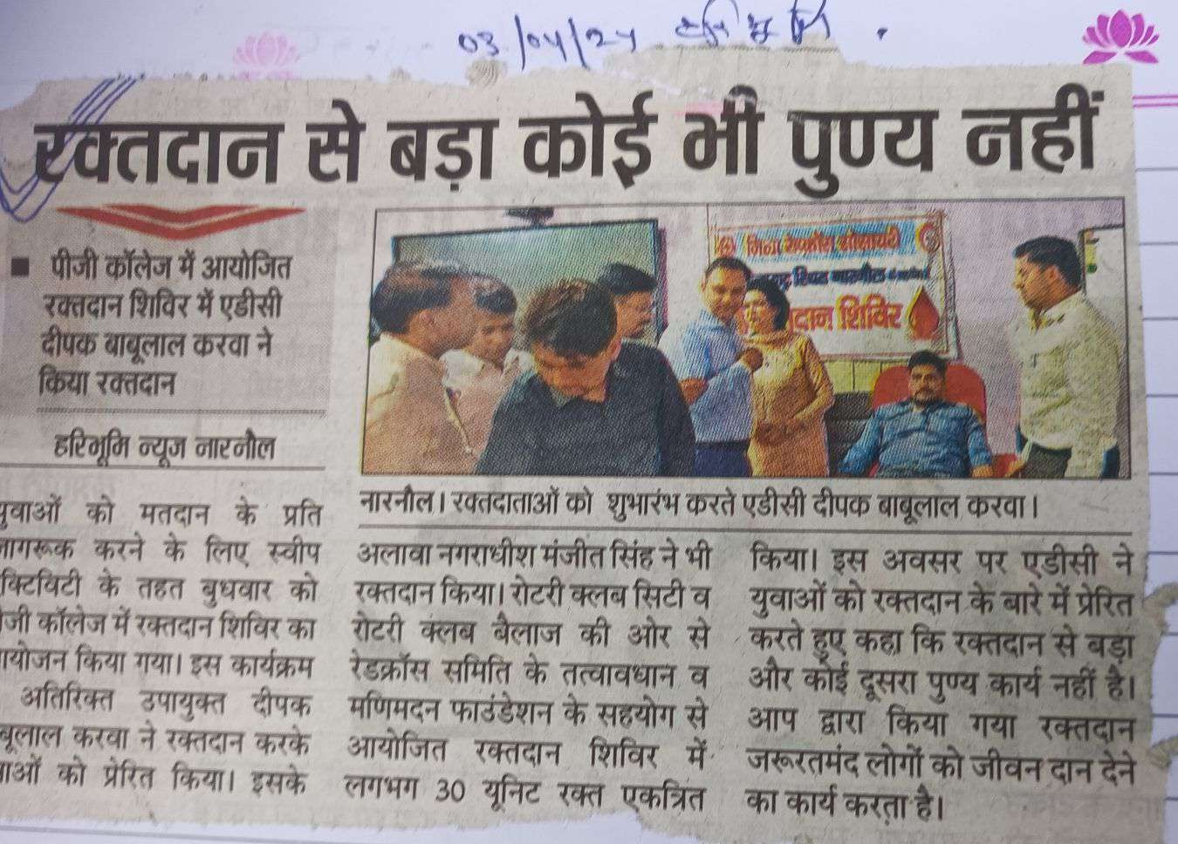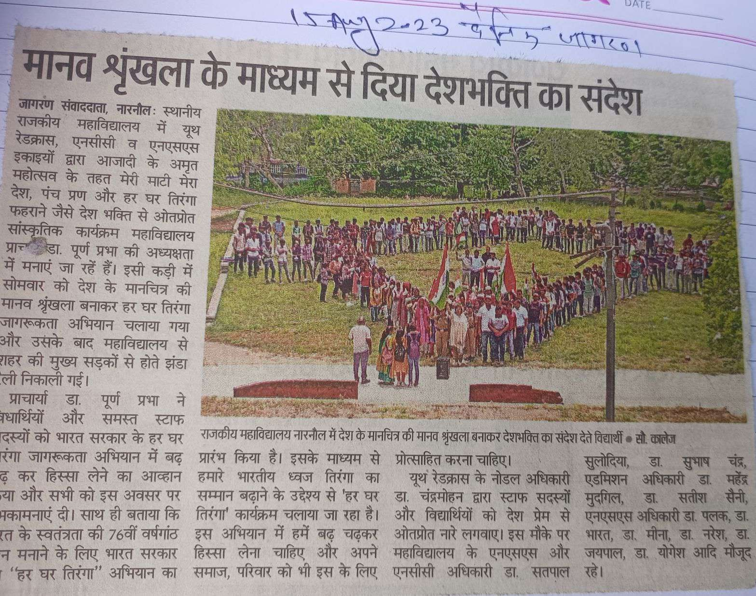s