BEST PRACTICES

1. Title of the Practice: **Gender Sensitization and Women Empowerment**

2. Objectives of the Practice:

• Equal opportunities for men and women in academic activities

• Equal opportunities for men and women in non – academic activities

• Fee concession to the deserving students

• To provide financial assistance to all deserving underprivileged students, regardless of caste or gender.

• To promote the ‘equality’ among the students.

3. The Context

A common consensus on education in the country reveals a significant disparity between the privileges accessible to girls and boys. It is past time for such discrimination to be abolished. Another point of contention was the disparity in privileges provided based on caste and economic standing. In such a period, it is critical that young minds are made aware of the problem and that they are encouraged to tear down long-held taboos. Equal opportunities to demonstrate solidarity with the given principle must therefore be provided by the institute.

4. The Practice

• Providing fee concessions for students with low economical standing.

• Creating awareness about equal rights and opportunities through various gender sensitization programmes

• Incorporating non academic activities promoting innate talents and aptitudes to encourage equal participation of all students regardless of gender.

• Mentoring women students on their specific issues with one women teacher as mentor for every mentees.

• Duties and restrictions imposed on each student and employee in the institution and institutional facilities, with specific security or consideration given to women in terms of leaves and schedules.

• Women have an open platform and direct access to a body called "internal complaint committee" where they can report acts of malice at work or school.

• "Women Empowerment Cell" was founded to protect women's rights and to develop a culture of respect and equality for women.

• For gender sensitisation and promoting gender equity debates and discussions are organized

5. Evidence of Success

The practise has created a better work/study atmosphere that recognises and celebrates each individual's contributions regardless of gender, caste, social class, or economic position. As a result of the training and speeches delivered, there has been a greater knowledge of human rights and basic fundamental rights. The creation of various units to promote gender equality and women's empowerment has resulted in an ongoing condition of peace with no instances of malevolent compliance.

6. Problems encountered.

• Implementation of the annual plan and its monitoring has become a toughtask in view of tight academic schedule.

7. Resources required

• Finance



This document contains information regarding specific facilities provided for women in terms of :

• Safety and Security 

• Counseling 

• Details of Various Activities to Promote Gender Equity

**SAFETY AND SECURITY**

➢ As a Co-ed college, GC Narnaul takes responsibility for providing a safe space for its students to learn and grow.

➢ The high walls of the campus also prevent the trespassers from entering the college premises

➢ The safety and security of students is a priority at the college during events and fests when the outsiders are also invited to the college campus

➢ Not only is our institution committed to women’s safety within the college campus, we are also engaged in making our community and neighbourhood safe for all women.

• Student life today throws up numerous challenges owing to a fast-paced tempo, changing family dynamics, being away from home, increased competitiveness and social media.

• GC Narnaul recognizes that counseling is important for students to navigate these demands and achieve their academic potential. In keeping with its mission to provide for the all-round holistic development of women students, our institution offers formal in-house counseling.

• This Counseling is free and open to all students and staff and complete confidentiality is maintained. It has contributed greatly in promoting the psychological well-being of students, helping them achieve their academic, personal, and relational goals.

• Some of the recurring student concerns flagged by the College Counselors are: Time, Stress, and Relationship Management, Family Problems, Body Image, Self Confidence, Career Counseling and Teething Problems faced by first year and outstation students.

GC Narnaul also has a strong Mentor-Ward Programme that complements the teaching-learning exercise. Every student is paired with a faculty-mentor, thus giving them the opportunity to reach out for individual sessions for counsel. Gender Sensitization are organized from time to time.

• The various initiatives launched by the college underlines that it takes responsibility for disseminating information on counseling as well as dispelling the myths and stigma surrounding it very seriously. This has helped students understand the significance of counseling and work on their own fears and anxieties.

**Gender Sensitization and Women Empowerment Programme**

|  |  |  |  |
| --- | --- | --- | --- |
| Session | Organising Unit | Activity Name | Date |
| 2023-24 | WDC | Participation in Mission Sahasi (Self defence Mega Event | 2-11-2023 |
| 2023-24 | WDC | Poster making competition & seminar on International Women’s Day | 08-03-2024 |
| 2023-24 | WDC | Self Defence And Taek Wondo Workshop for ten days | 02-02-20 24 to 12-02-2024 |
| 2023-24 | WDC | Poshan Pakhwada | (09-03-2024 to 23-03-2024) |
| 2023-24 | Management Deptt. | Don’t Abuse Women Programme | 2023-24 |

**Participation in Mission Sahasi (Self defence Mega Event organised by Women Cell, IGU,** 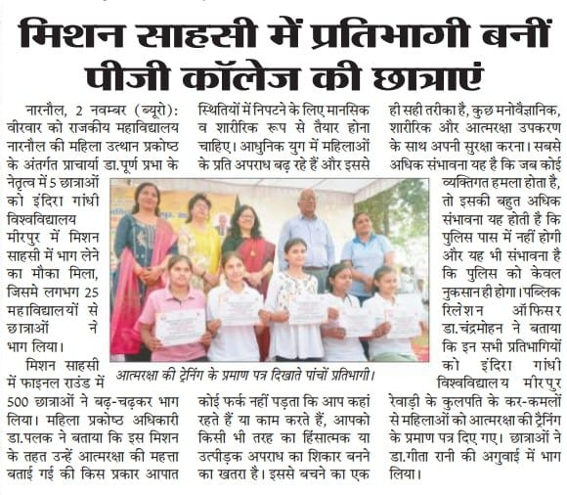

**International Women’s Day (08-03-2024)**

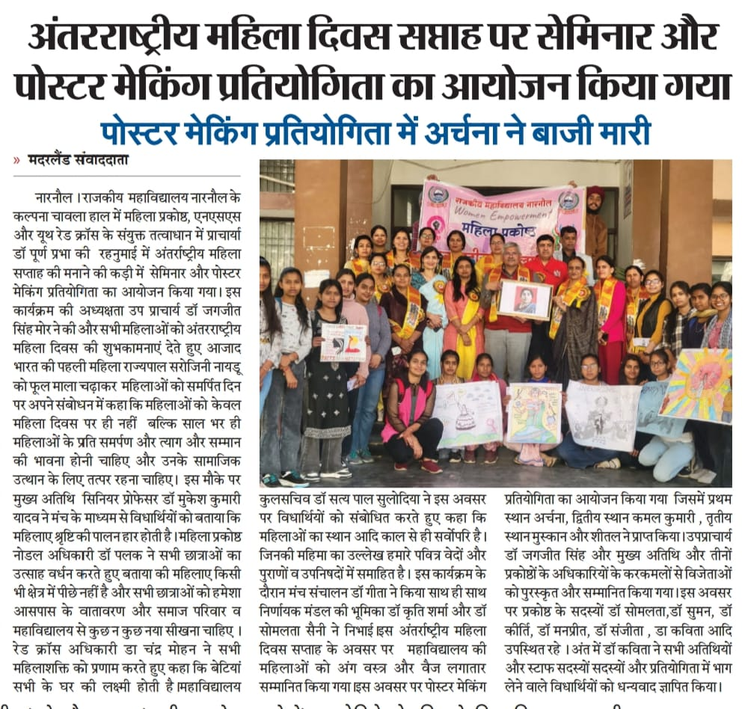

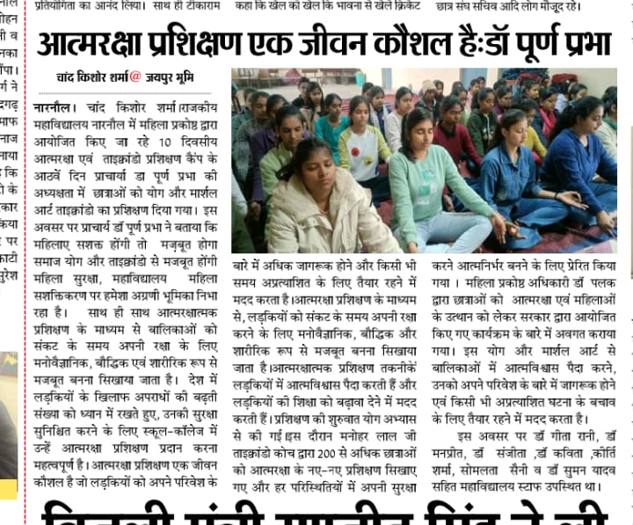**Self Defence And Taek Wondo Workshop for ten days, organized by Women Development**

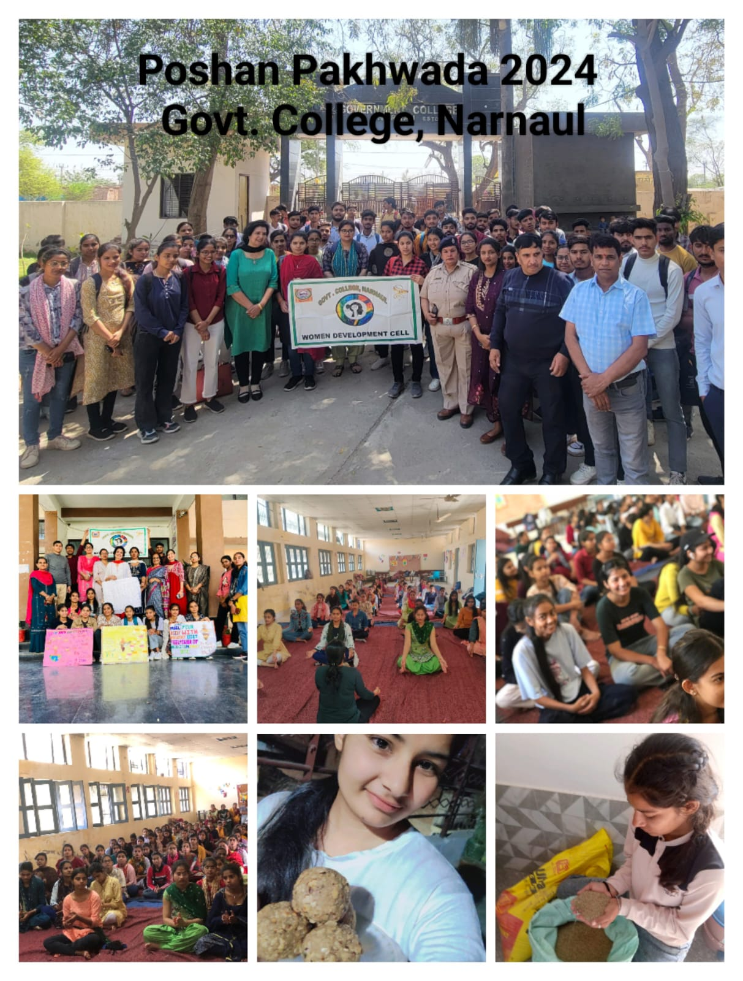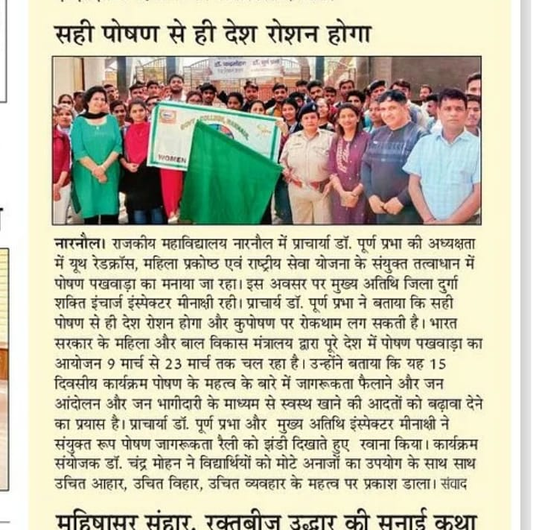**Poshan Pakhwada (09-03-2024 to 23-03-2024)** 