# OFFICE OF THE PRINCIPAL

**GOVERNMENT COLLEGE, NARNAUL**

**Matrix No. 7.3.1**

**Women Empowerment through Education**

# Introduction

Government College Narnaul established in 1954, may boast of its pioneering work in the realm of gender equality and sensitisation of girl students to evolve themselves to become proactive participants in influencing the direction of positive social transformation. The genuine efforts of the institution in this direction and more than satisfying goals achieved to this effect make us feel a sense of satisfaction that the institution has succeeded in discharging its duties in the best possible manner in making the girl students self-confident, employable, educated and harbinger of change in the society.

# Mahendergarh

Mahendergarh, a small town of South Haryana, is still labelled as a backwards district despite being a district since Haryana came into existence on 1st 1966. Most of the girl students who choose Govt. College Narnaul came from rural areas and belonged to disadvantaged and marginalised groups.

# Vision

An institution with a positive impact on society, by providing innovative affordable education to students by equipping them with the knowledge and skills necessary to succeed in their chosen fields and helping them to reach their full potential and became future leaders, business owners and most importantly good human being.

Mission

To create a better education environment by offering state of art infrastructure and quality human resource and nurture students to attain academic brilliance, civic culture and became enlightened citizens. To prepare students from different sectors of society to complete globally and moulding them in to future nation makers or builders. The Principal,Academic coordinator and Staff members are involved in defining the policies and procedures, framing guidelines, rules and regulations pertaining to admission grievance, counselling, placement and discipline.The Vision of women's empowerment inspires us:



* To provide quality education with self-confidence, inculcation of ethics, fostering independent thinking and pursuit of excellence, sensitisation to social and environmental needs and a holistic and global outlook on life.
* To create a student-centric learning environment driven by a passion for excellence, research culture, and an eco-system for innovation and creativity.
* To encourage a participatory approach among staff students, alums and other stakeholders
* To provide adequate opportunities to engage in a multitude of interests of our diverse student community in academic, co-curricular and extra-curricular activities.
* To provide them easy access to quality higher education and job opportunities
* To have a Management that would uphold the highest levels of transparency, accountability and governance

# Gender Disparity and Reservation

Fully aware of their rural and socio-economic background, the college has a robust Institutional mechanism to actualize its goals of gender equality and works ceaselessly to mitigate gender disparity. The college starts its pivotal role of mitigating gender disparity by offering reservation in admissions to U.G./P.G. classes to students belonging to SC/OBC/PH and EWS Categories. At the very start of the academic session, the girl-students are familiarised with the different cells and Activities undertaken in the college.Such programmes instil a sense of confidence in the newcomers and prepare a perfect Platform for them to choose activities of their preference to further the cause of holistic development.

# Counseling

Student life today throws up numerous challenges owing to a fast-paced tempo, changing family dynamics, being away from home, increased competitiveness and social media. GC Narnaul recognises that counselling is essential for students to navigate these demands and achieve their academic potential. In keeping with its mission to provide for the all-round holistic development of women students, our institution offers formal in- house counselling. This counselling is free and open to all students and staff, and complete confidentiality is maintained. It has significantly promoted students' psychological well- being, helping them achieve their academic, personal, and relational goals. Some recurring student concerns flagged by the College Counsellors are Time, Stress, Relationship Management, Family Problems, Body Image, self-confidence, Career Counseling and Teething Problems faced by first-year and outstation students. The institution also has a robust Mentor-Ward Programme that complements the teaching-learning exercise, and every student is paired with a faculty mentor, thus allowing them to reach out for individual sessions for counsel. Various talks on Gender Sensitization are organized from time to time. The various initiatives launched by the college underline that it takes responsibility for disseminating information on counseling and seriously dispelling the myths and stigma

surrounding it. This has helped students understand the significance of counseling, work on their fears and anxieties and achieve their best in curricular and extra-curricular activities.

# Earn While You Learn Scheme

Earning while learning mechanism is another vital tool for the girl-students to empower themselves. The college administration provides opportunities to about 40 students every year to work for an hour daily in the different depts./offices and apart from familiarizing them with the work culture of the offices/depts which will stand them in good stead when they will work under their prospective employees, also brings in them a sense of financial independence-a sense that they are employable and may earn their livelihood with pride and dignity.

Providing financial assistance to the poor and needy students from SC and OBC categories is another critical measure the institution took to empire the girl students. Another essential feature adopted by the institution to bring about gender equality is waiving tuition fees for UG students. From 2023-24 onwards, this facility has been extended to all PG students, irrespective of their income category. A significant hurdle the girl students face, most of them hailing from rural areas, is the cost of commutation from their homes to the college. To address this problem and to mitigate their travelling expense, a bus-pass facility is provided to the girl students, and almostgirl students are availing themselves of this facility. This measure of the college is among the most significant and influential mechanisms to empower girl students because easy and free accessibility to transport facilities ensures unhindered education to girl students and paves the way for their empowerment.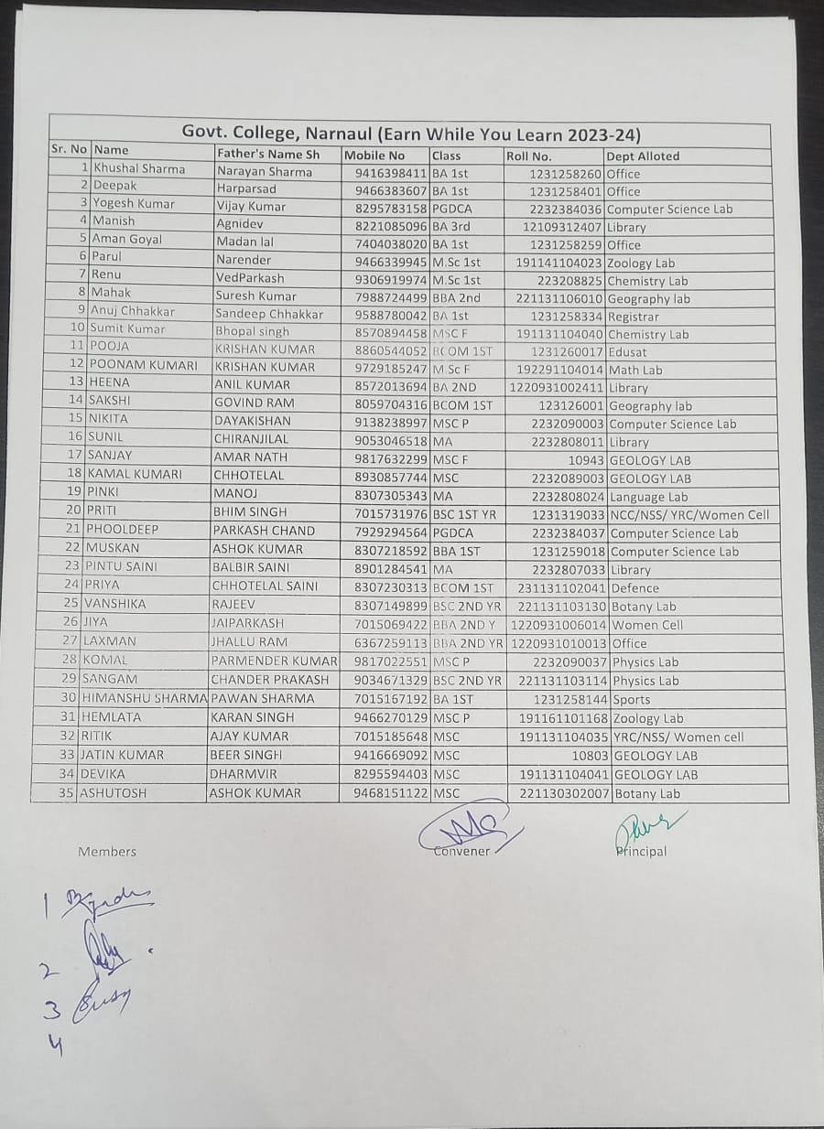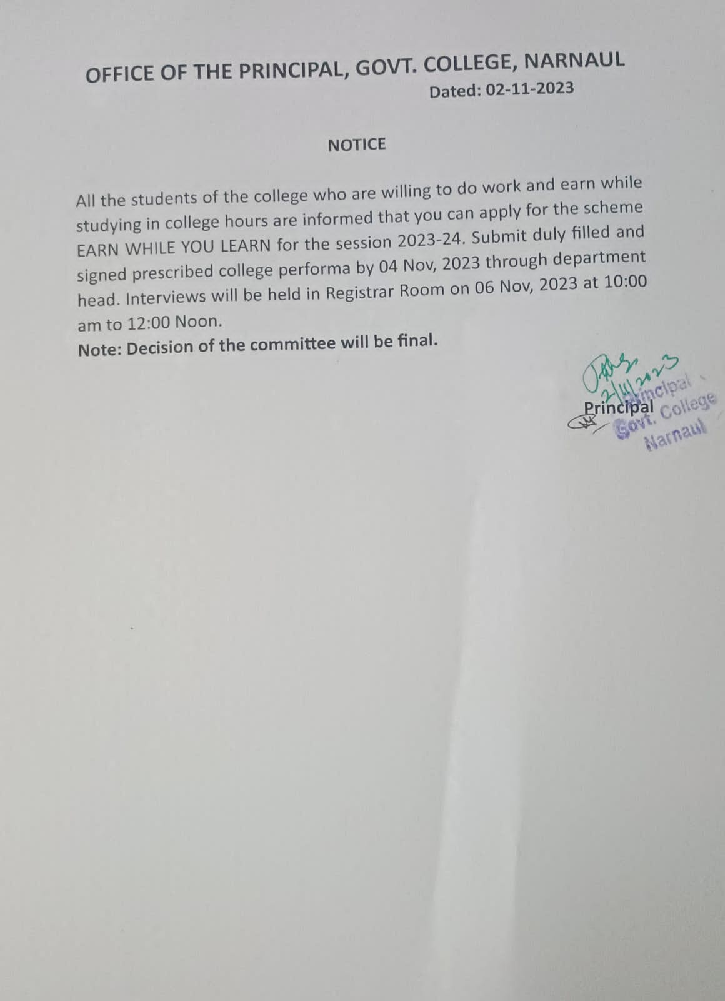

# Awareness of Laws

The college makes the girl-students familiar with the existing laws and remedies available to them from all types of exploitation, whether physical, sexual, economic or caste and gender-based. The legal cell of the college keeps on holding. In seminars, eminent lawyers are invited to impart the girl-students' legal knowledge that can be used to thwart any exploitation. Through such workshops, they are also sensitised towards female-facticide, anti- dowry, and domestic violence laws. Competitions are also held under the aegis of the legal cell to strengthen their awareness of their rights.

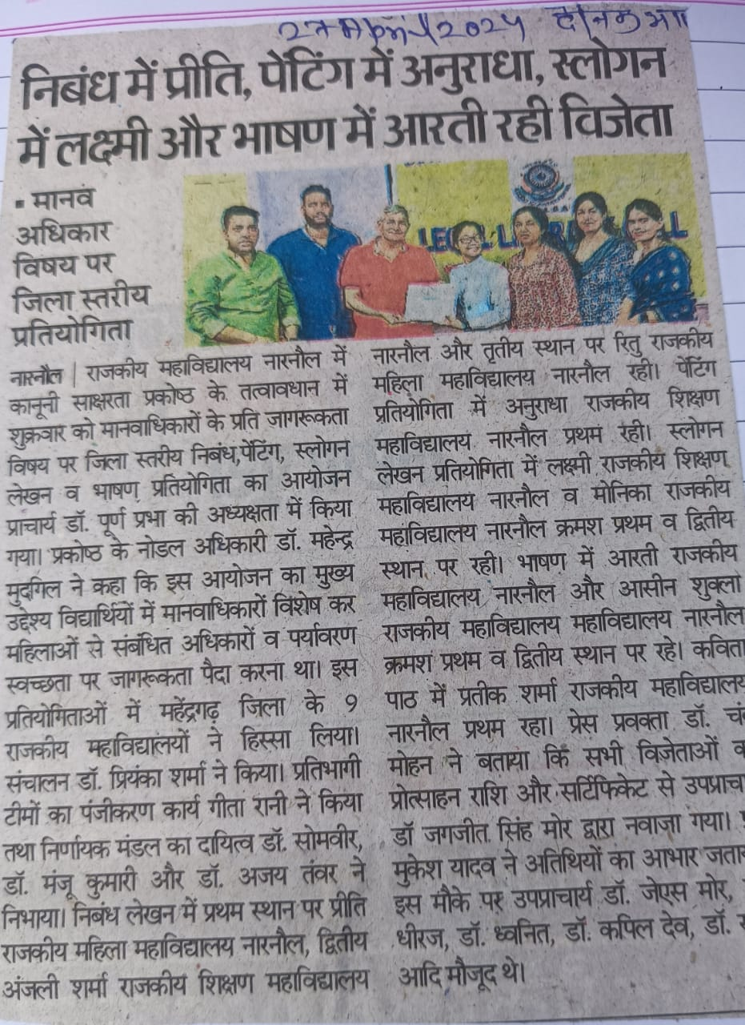

# Cultural Activities

The institution also holds Talents as a suitable platform to showcase their talents. The cultural activities hosted by the college and teams sent by it to different colleges for the participation of girl-students in cultural activities help them ward off their inhibitions and open new vistas for them. Such activities add a new dimension to their personality, enhancing their vibrancy and zestfulness. Different clubs have been formed in the college, and various activities viz. Sports,cultural,red ribbon club.

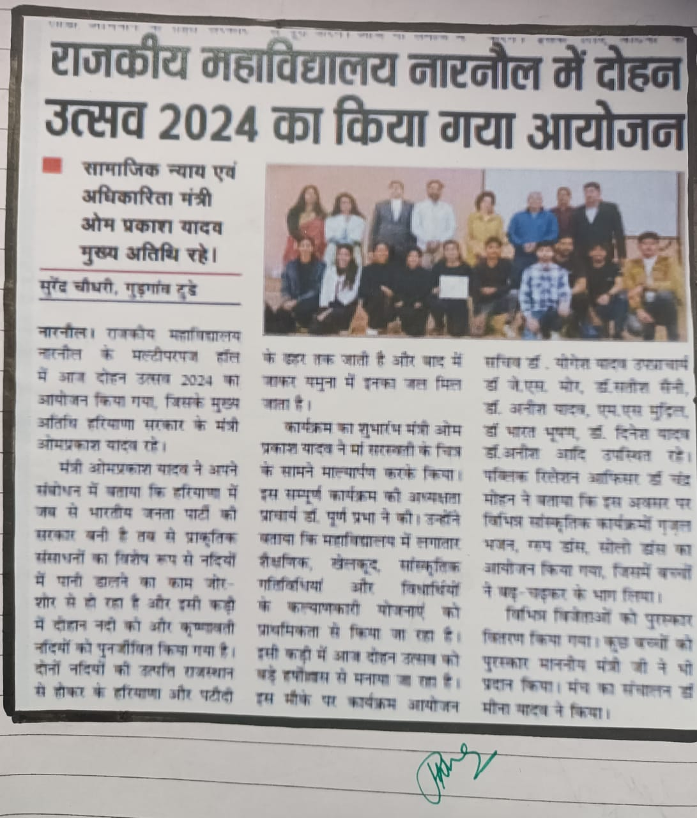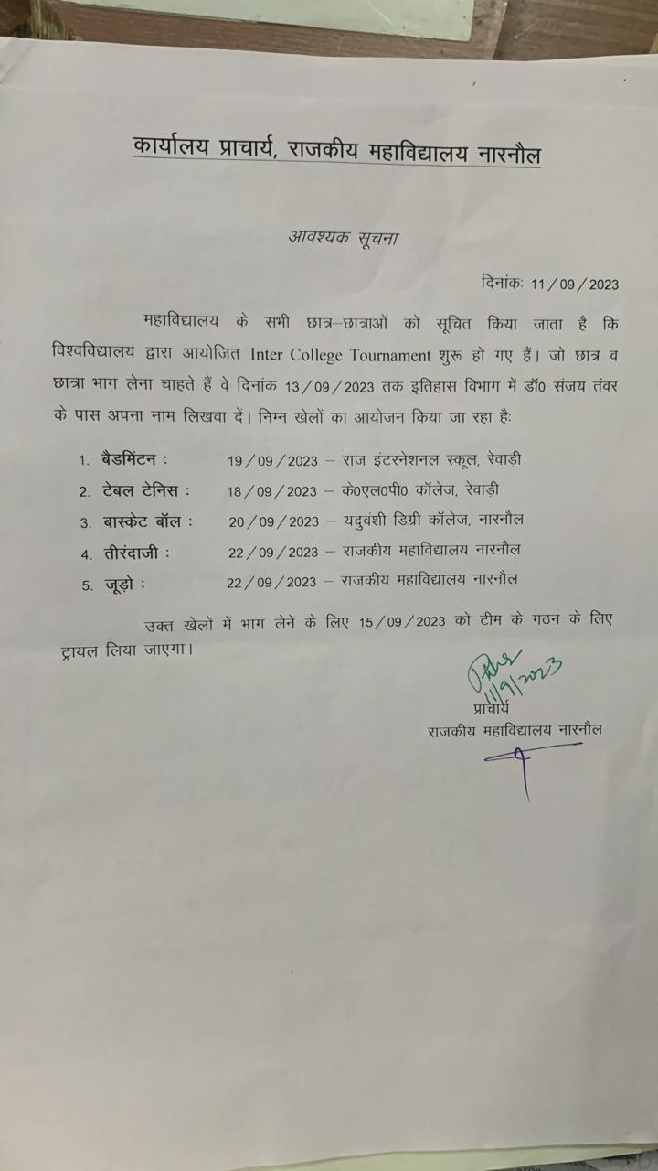

# Vocational & Self Defense Training

Apart from the activities mentioned above/measures taken by the college in the direction of women's empowerment and gender sensitisation, the proactive role of the college's women's cell is exemplary. The women's cell of the college organises "Self-defence Training classes" to infuse a sense of security among the girl students. The training and tips imparted to them during their classes help the girls thwart eve-teasing attempts of the rogues. Another significant initiative in the direction of women's empowerment taken by the women's cell pertains to organising tailoring and knitting,embroidary classes. These classes/workshops help the girl-students learn new skills which will prove handy to them to become self-reliant and self-employed. The cell also arranges lectures of specialists such as gynaecologists and s sensitise them about the various health issues relating to the menstruation period, slain diseases, etc. The cell also ensures that vending machines and interceptors work efficiently, and the tendency of using uncless clothes during the musteration cycles by some of the girl-students belonging to rural and marginalised groups is curbed. With the help of specialist doctors and NGOs, the girl-students are also motivated to shun fart foods and adopt-healthy and nutritious diets. By organising Yoga classes and with the help of psychologists, the students' Physical, spiritual and mental aspects are addressed. 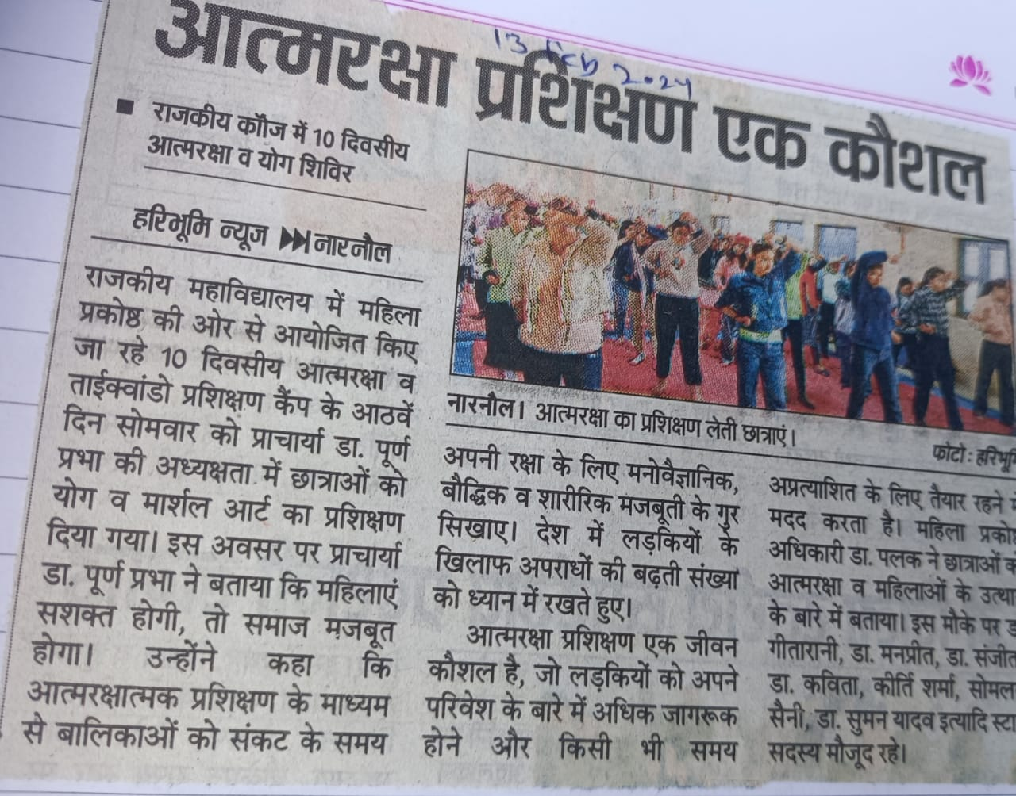

# The Placement Cell of the College

The main aim of studying in the life of our young students is to acquire knowledge and find a job according to one's ability. The sole purpose of studying in a college of repute is the desire for a better placement. Every student wants to get a job in a company or a Government job of her choice or acquire knowledge during college to start one's own business.

To get proper guidance, Students depend on the college Placement Cell for a better future. Keeping these hopes and needs of the students in mind, the Placement Cell is working in the institution, and it serves as an interface between the students and the employer. The Placement Cell also organises various seminars, workshops and extension lecturers.

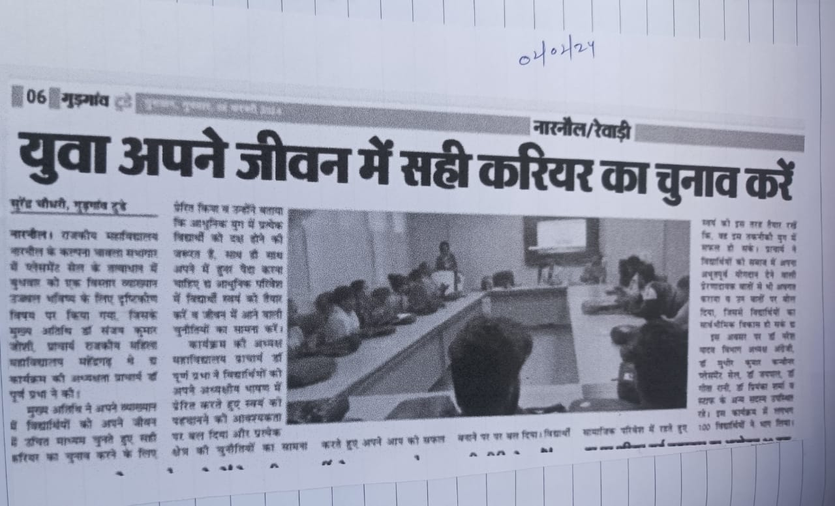

# Mentoring

Mentoring benefits all students. For some students who may be experiencing social isolation, mentoring can be a much-needed emotional and social support. For other students experiencing academic challenges, it can be an effective strategy for building a new or renewed love of learning and literacy. The college has assigned duties for the teachers as Mentors for a specific group. These mentor groups have played a significant role in:

* Building students' sense of belonging within the school community
* Enhancing attendance and motivation to learn
* Helping individual students feel more connected and valued in their school community
* Helping students learn about and value diversity
* Encouraging individuals to get to know one another, identify common interests and concerns, recognise one another's strengths and contributions

**Links for Photographs of Activities/Trainings/Workshops For**

**Women Empowerment**

1. **BMI calculation and Awareness Workshop (12-10-2023)**
2. 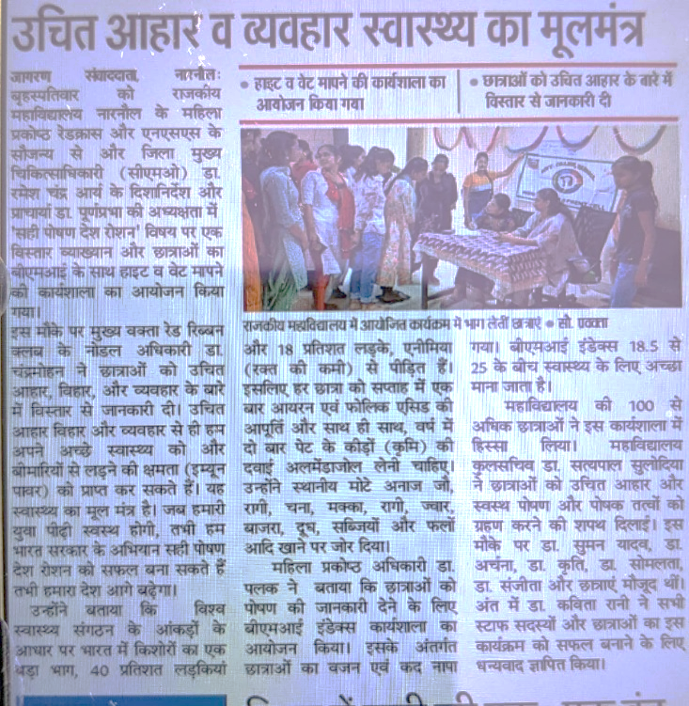

**Voters Awareness Camp (06-10-2023)**

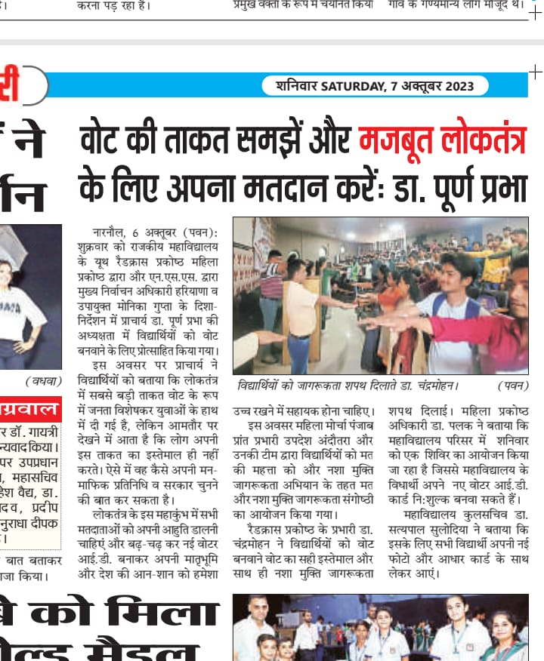

**Mehandi Competition on Karva Chauth**

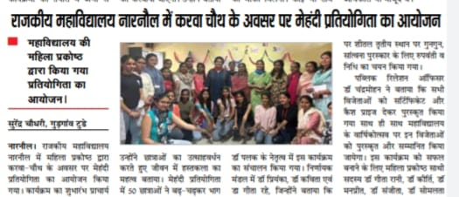

**Participation in Mission Sahasi (Self defence Mega Event organised by Women Cell, IGU, Meerpur) on 2-11-2023**

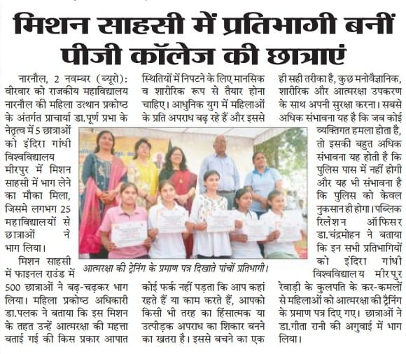

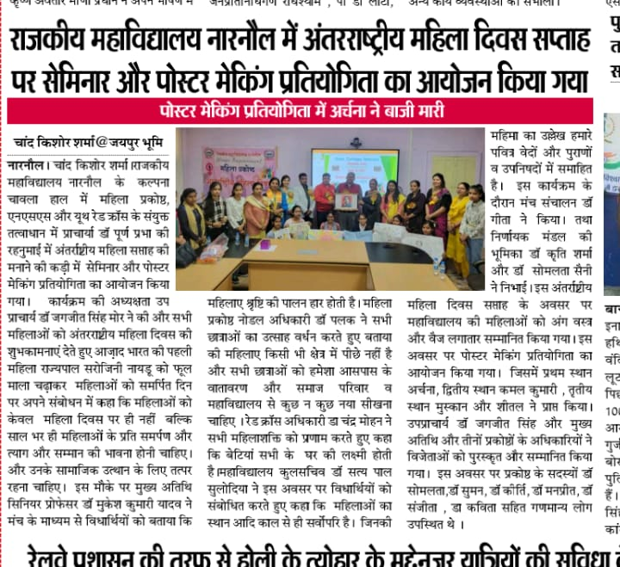 **International Women’s Day (08-03-2024**) 